

Year 6 - Branch 6
Dialogue and Encounter

Key Vocabulary
Dialogue | 
World View | 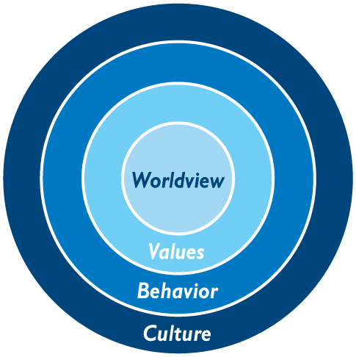
Catholic Social Teaching | 
Dharmic | 
Scripture |  |  | Catholic Social Teaching Dignity
  …The second is like: ‘You shall love your neighbour as yourself.’.  Matthew 22:39 |  |  | "The dignity of others is to be respected in all circumstances...  Pope Francis

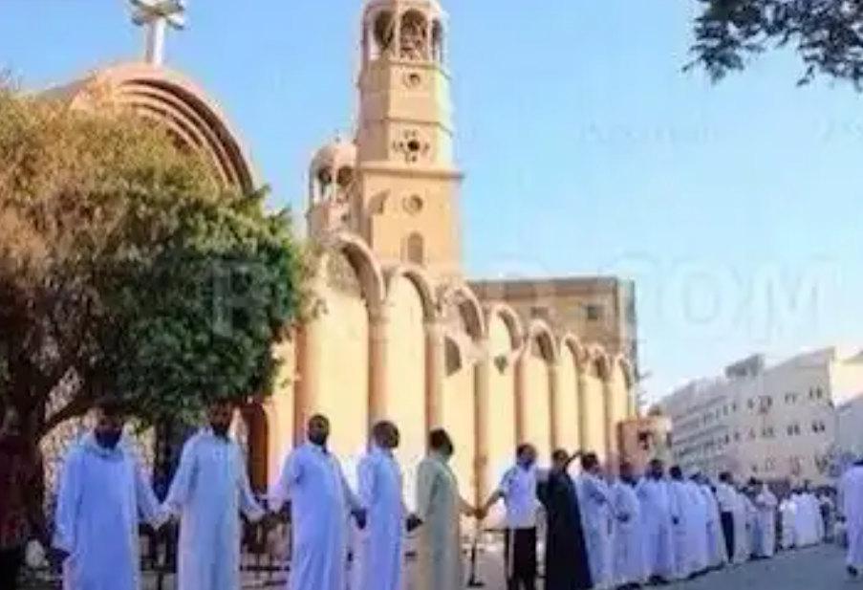
Muslims outside the Catholic Church, Egypt.

See Think Wonder

BIG Question: How can dialogue change the world for the better?

