


Year 5 - Branch 6
Dialogue and Encounter

Key Vocabulary
Old Testament | 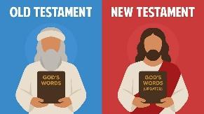
New Testament
Bible | 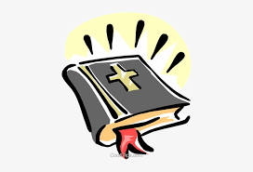
Tanakh | 
Shema | 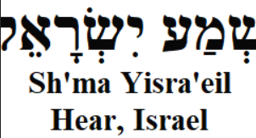
Mezuzah | 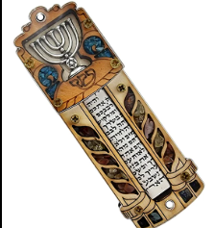
Scripture |  |  | Catholic Social Teaching  Dignity
  All Scripture is inspired by God.  2 Timothy 3:16 |  |  | "The dignity of others is to be respected in all circumstances...  Pope Francis

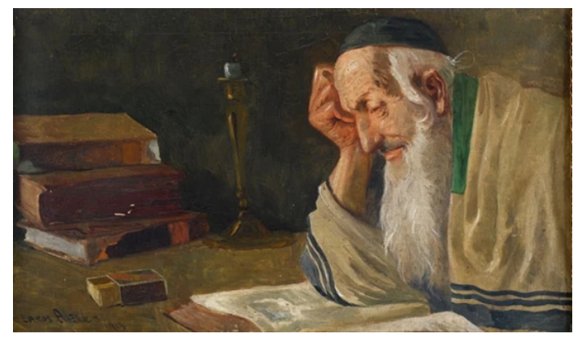
BIG Question
How does God’s word help people live faithfully?
Rabbi studying Torah by Alfred Lakos
See Think Wonder

See Think Wonder

