

Year 2 - Branch 6
Dialogue and Encounter

Key Vocabulary
Samaritan | 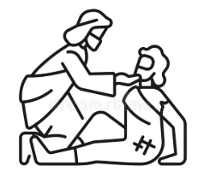 | A person who helps others.
neighbour |  | Someone we can love and help.
respect |  | Being kind and caring to others.
Sabbath |  | A special day to rest and pray.
Shabbat | 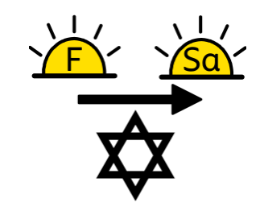 | The Jewish Sabbath, a special day to rest and pray.
synagogue |  | A special place where Jews talk to God.
Scripture
…Jesus said to him, “Go and do the same.”
St Luke’s Gospel
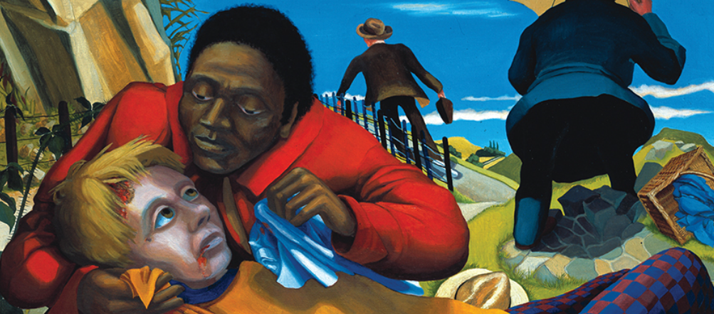

BIG Question
Who is my neighbour today?

Catholic Social Teaching
Dignity
Every single person is special, loved by God, and must be treated with kindness because God made them.


Good Samaritan by Dinah Roe Kendall
See  Think  Wonder 

