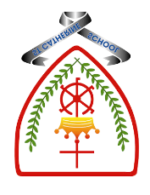
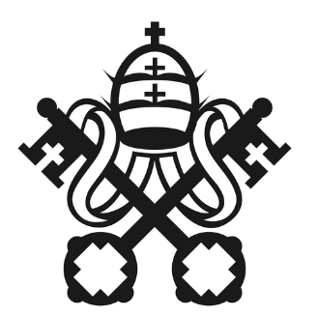
Year 1 - Branch 6
Dialogue and Encounter

Christian | 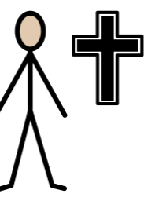 | A person who follows Jesus.
Church | 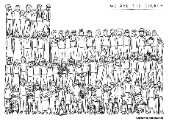 | A place where people pray to God.
Parish | 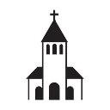 | A group of people who help and care for each other.
Sign of the Cross | 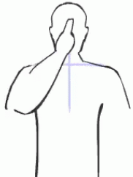 | A prayer we make with our hand.
Judaism | 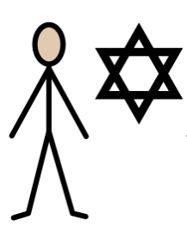 | Jewish people follow God and His teachings.
Torah |  | A special, holy book for Jewish people.
Scripture |  |  | Catholic Social Teaching  Dignity
  Whoever does God’s will is my brother and sister and mother.  St Mark’s Gospel |  |  | Every single person is special, loved by God, and must be treated with kindness because God made them.  

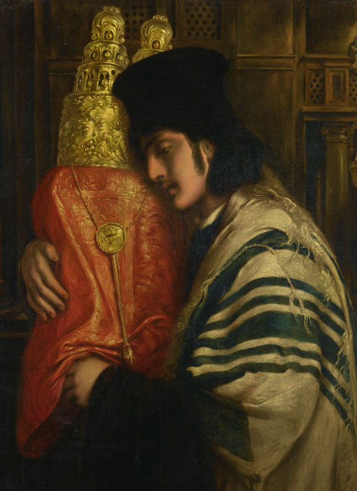
BIG Question
What does it mean to belong to God’s family?

See
Think
Wonder

Carrying the Scrolls of Law by Simeon Solomon

