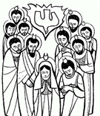
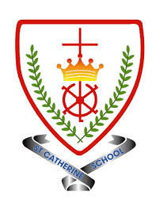

EYFS Branch 5
To the Ends of The Earth

Key Vocabulary
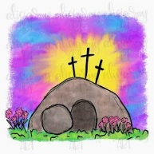 | Easter | 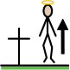 | Resurrection
 | Holy Spirit |  | Pentecost
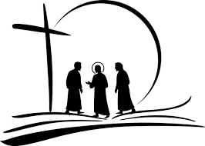 | Apostle | 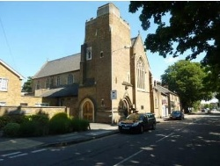 | Church
 | family | 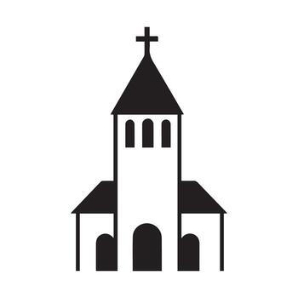 | parish
 |  | community

BIG Question
Where did Jesus go after Easter?
Catholic Social Teaching
Dignity of Workers
Do we say thankyou to those who work to help us?

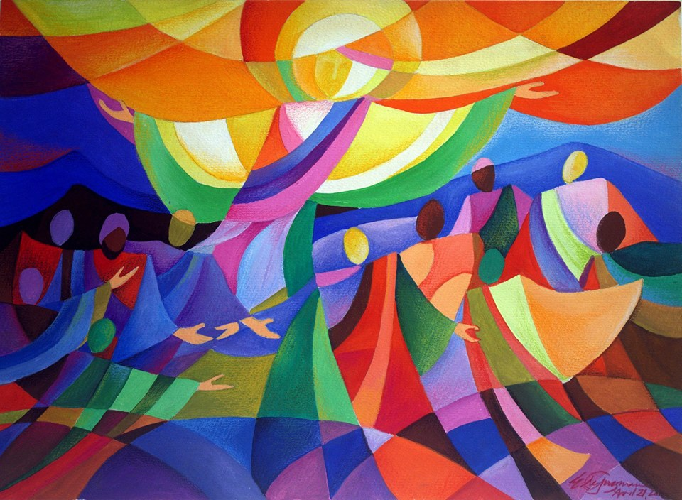

See 
Think 
Wonder 

