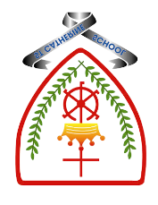

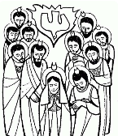
Year 6 - Branch 5
To the Ends of The Earth

Key Vocabulary
Adam | 
Mary Magdala | 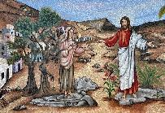
Resurrection | 
martyr | 
witness | 
saint | 
charity | 
Scripture |  |  | Catholic Social Teaching Dignity of Workers
  Early on the first day of the week, while it was still dark, Mary Magdalene went to the tomb and saw that the stone had been removed from the entrance. John 20:1 |  |  | There is no worse material poverty… than the poverty which prevents people from earning their bread and deprives them of the dignity of work. Pope Francis
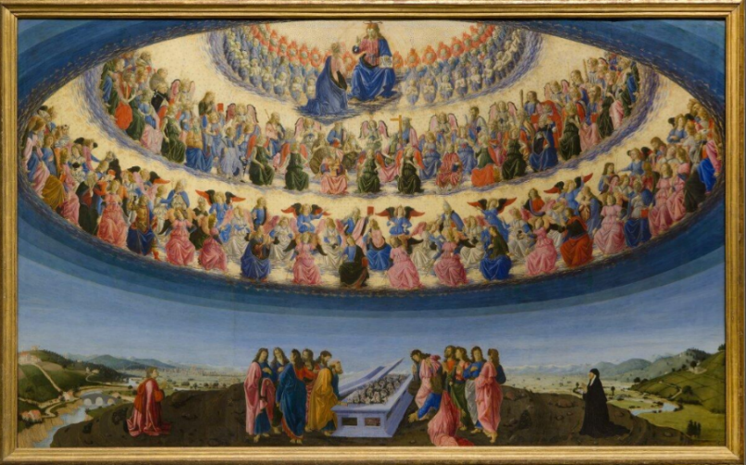
See Think Wonder

Assumption of Our Lady: Botticini (1475)
BIG Question: What connections can you make between The Resurrection and The Creation story?


