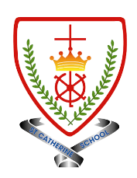
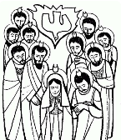
Year 5 - Branch 5
To the Ends of The Earth

Key Vocabulary
confirmation | 
discipleship | 
Holy Spirit | 
anoint | 
chrism | 
Bishop | 
baptismal grace | 
Scripture |  |  | Catholic Social Teaching  Dignity of Workers
  All of them were filled with the Holy Spirit and began to speak in other tongues as the Spirit enabled them.  Acts 2:4 |  |  | There is no worse material poverty… than the poverty which prevents people from earning their bread and deprives them of the dignity of work. Pope Francis
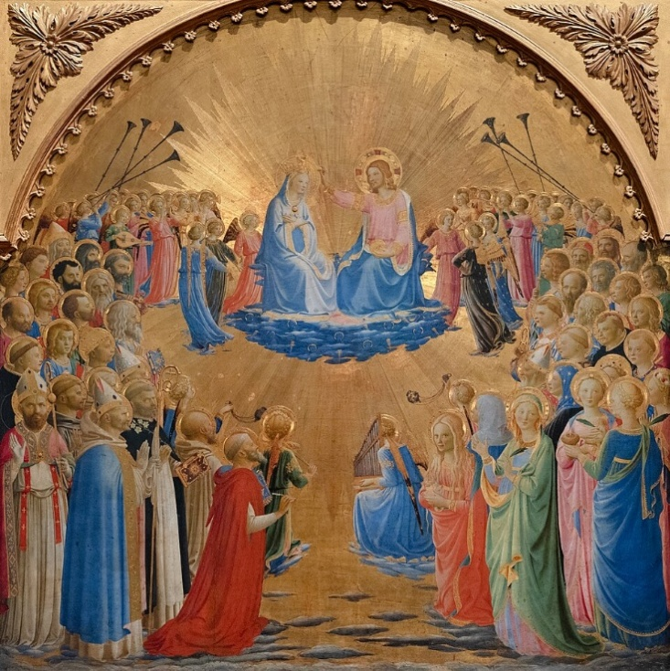

BIG Question
How does Confirmation strengthen Catholics to respond to their faith?
See  Think  Wonder 

Coronation by Fra Angelico 1432

