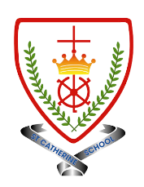
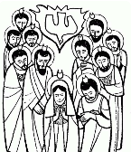
Year 4 - Branch 5
To the Ends of The Earth

Key Vocabulary
Church | 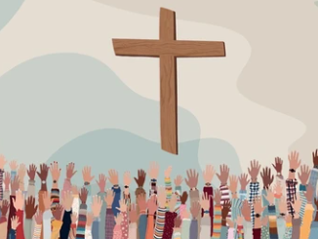
Pope | 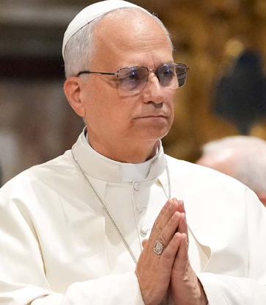
Apostles/ apostolic | 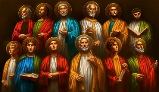
Creed | 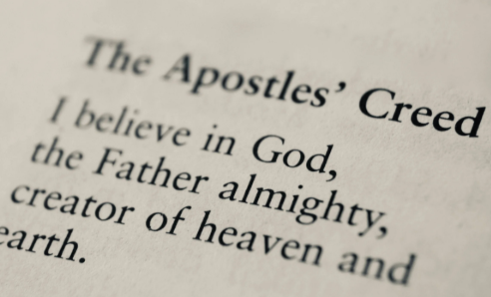
people of God | 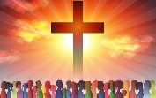
communion of saints | 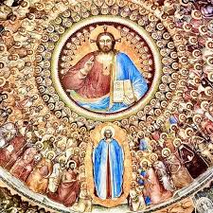
Mary Mother of the Church | 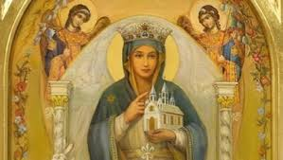
Scripture |  | Catholic Social Teaching  Dignity of Workers
  He saw and believed.  The Empty Tomb  St John’s Gospel |  |   Work is fundamental, It 'anoints' us with dignity, makes us like God Pope Francis
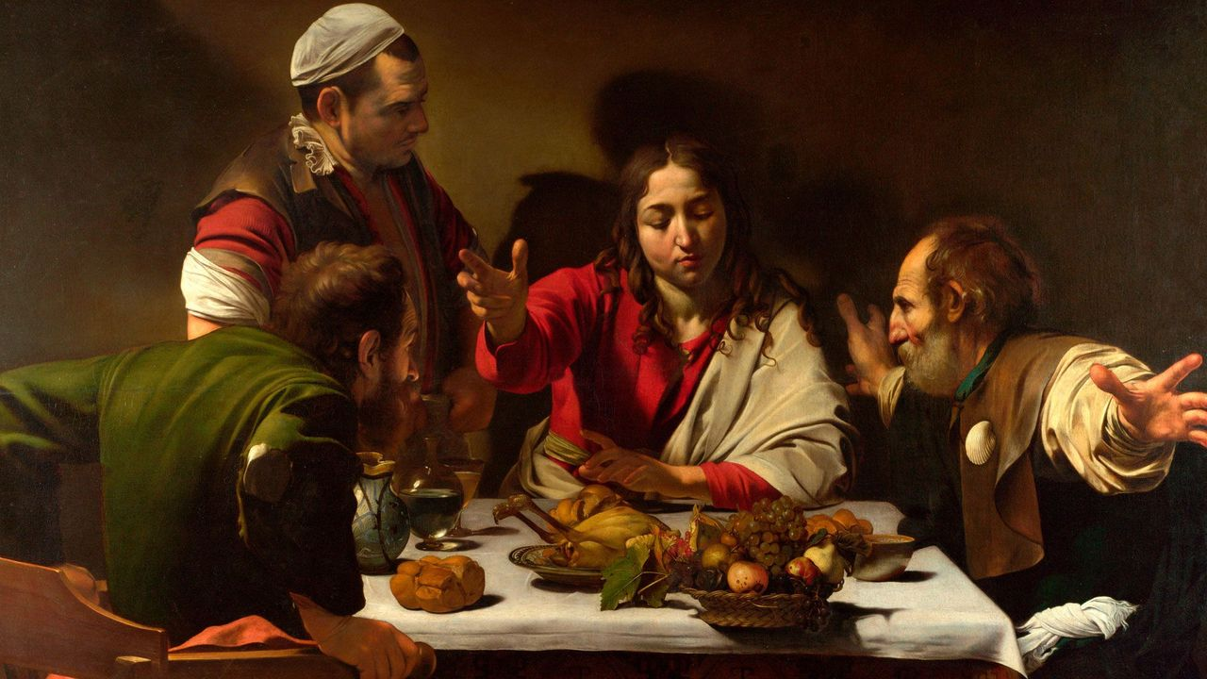

Supper at Emmaus – Caravaggio (1601)
BIG Question
How does The Church continue Jesus’ Mission in The World today?
See  Think  Wonder 

