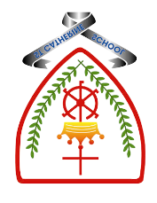

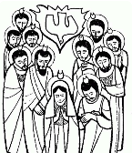
Year 3 - Branch 5
To the Ends of The Earth

Key Vocabulary
Emmaus | 
Holy Spirit | 
Pentecost | 
concluding rite | 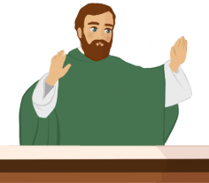
St Paul | 
discipleship | 
Scripture |  | Catholic Social Teaching  Dignity of Workers
  Then their eyes were opened and they recognized him  The Road to Emmaus  St Luke’s Gospel |  | Work is fundamental, It 'anoints' us with dignity, makes us like God: Pope Francis  
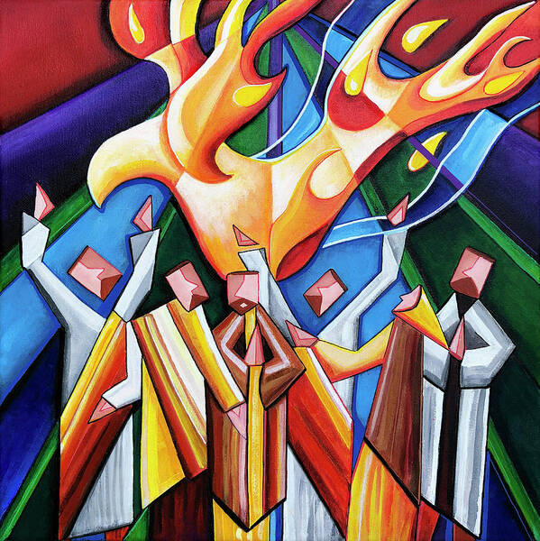
See , Think , Wonder 


BIG Question
What is The Holy Trinity?
Pentecost by Jennifer Allinson

