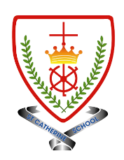
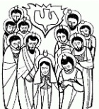
Year 2 - Branch 5
To the Ends of The Earth

Key Vocabulary
Holy Spirit |  | God who lives in our hearts and acts through us in the world.
Ascension | 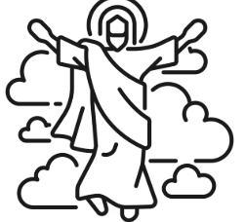 | Jesus returning to heaven.
Pentecost |  | When The Holy Spirit came to help the disciples.
Saul |  | Saint Paul’s name before he knew Jesus.
prayer |  | Talking and listening to God with our hearts and minds. We can say please, thanks, or sorry.
Fruits of the Spirit | 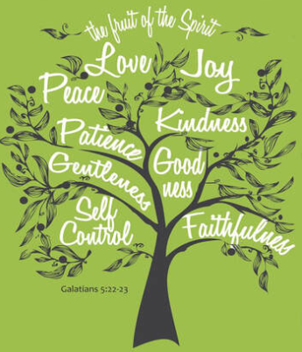 | The good things we show when we are helped by The Holy Spirit.
Scripture |  |  | Catholic Social Teaching  Dignity of Workers
  Jesus himself stood among them and said to them, “Peace be with you.” ³⁷ They were startled and frightened.  St Luke’s Gospel |  |  |   How do we treat people who work to help us?

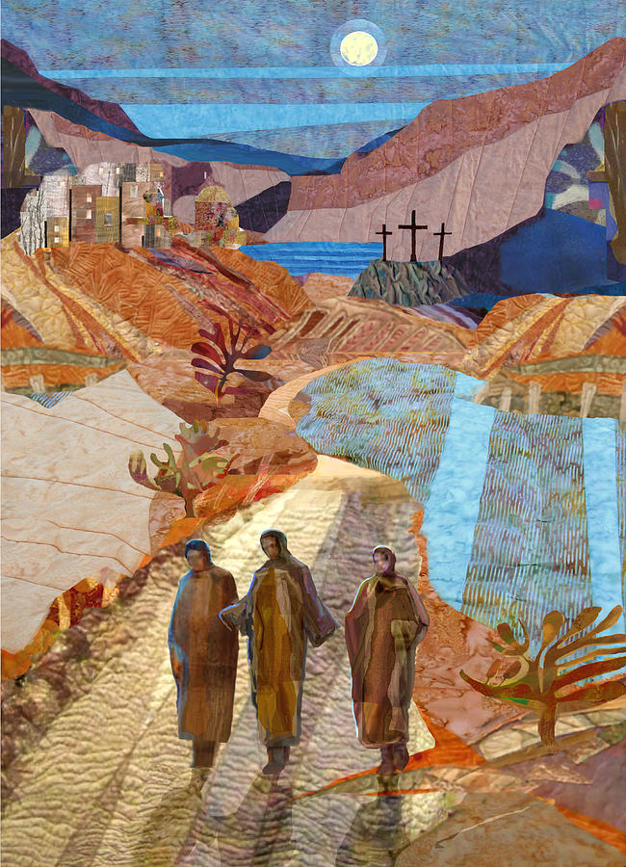

BIG Question
How does the Holy Spirit change people?

See  Think  Wonder 

Road to Emmaus by Michael Torevell

