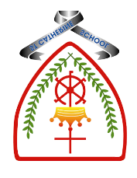

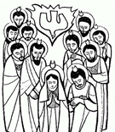
Year 1 - Branch 5
To the Ends of the Earth

Emmaus |  | The place two friends were walking to when they met Jesus.
Holy Spirit |  | God who lives in our heart
Ascension | 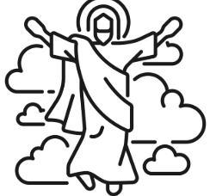 | Jesus going back to Heaven
Pentecost |  | The Holy Spirit coming to The Disciples
Church | 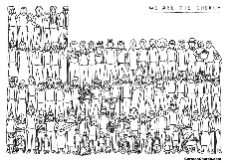 | The family of people who believe in Jesus and follow His word
Glory Be | 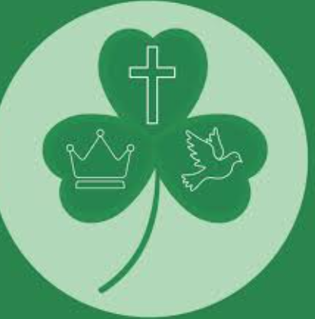 | A short prayer teaching us about and praising God
Gospel |  | The story of Jesus’ life that we read and learn from
Scripture |  |  | Catholic Social Teaching  Dignity of Workers
  They saw what seemed to be tongues of fire that separated and came to rest on each of them.  The Acts of The Apostles |  |  |   How do we treat people who work to help us?

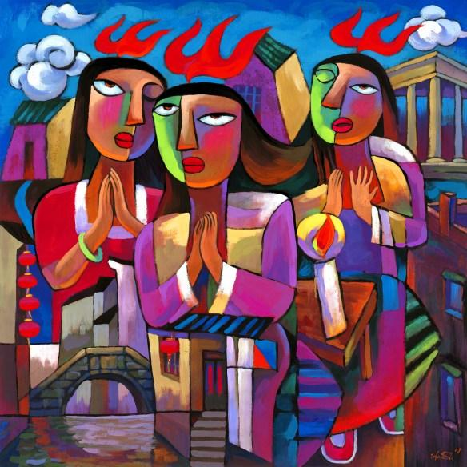
BIG Question
How did the Holy Spirit help Jesus’ friends to change?

See
Think
Wonder

Pentecost: a painting by He Qi

