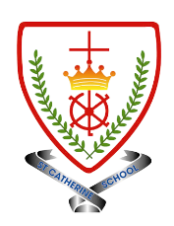
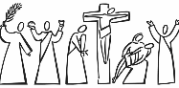
Year 6 - Branch 4
Desert to Garden

Key Vocabulary
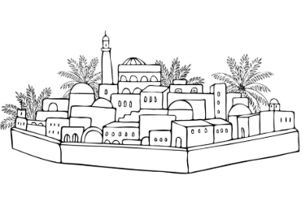 | Bethany
 | Anoint
 | Discourse
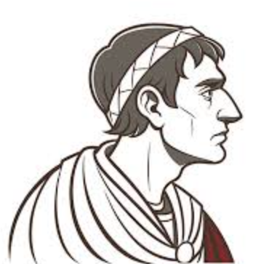 | Pilate
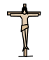 | Crucifixion
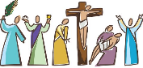 | Holy Week
XIV | Stations of The Cross
Scripture |  |  | Catholic Social Teaching  Community and Participation
  You will always have the poor among you, but you will not always have me.  Jn 12:1-11 |  |  | 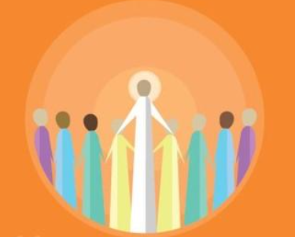  Pope Francis said “Do not be observers of life: get involved like Jesus did”
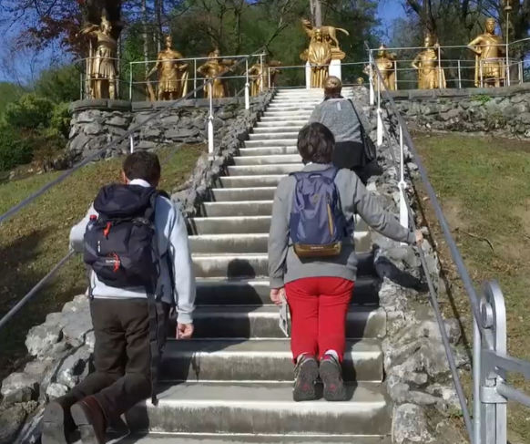

BIG Question
Which of the events in Holy Week is the most important in explaining who Jesus is? Think about the different names we know Jesus by.
See  Think  Wonder 

Station of The Cross: Lourdes, France.

