
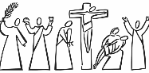
Year 5 - Branch 4
Desert to Garden

Key Vocabulary
 | Ash Wednesday
 | Lent
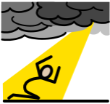 | Sin  (Deadly Sin)
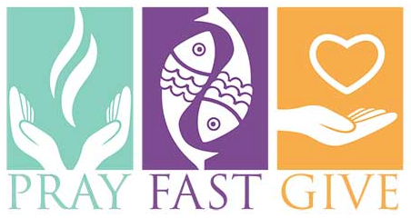 | Fasting
 | Prayer
 | Conscience
 | Death
 | Judgement
 | Heaven/ Hell
Scripture |  | Catholic Social Teaching  Community and Participation
  If you are the Son of God, throw yourself down.  Mathew 4:5 |  | 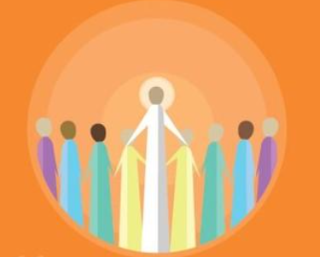  Pope Francis said “Do not be observers of life: get involved like Jesus did”

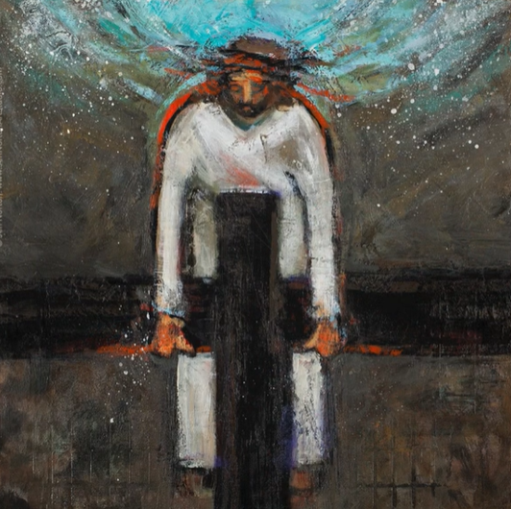
Station Two – Jen Norton
BIG Question
What does the priest say when he distributes Ashes? Why is this an important message for Lent?
See  Think  Wonder 

