

Year 4 - Branch 4
Desert to Garden

Key Vocabulary
 | Lent
 | Holy Week
 | Parable
 | Sin
 | Forgiveness
 | Mercy
Scripture |  | Catholic Social Teaching  Community and Participation
  “…before the cock crows, you will deny me three times”  Matthew 26:34 |  |   Pope Francis said “Do not be observers of life: get involved like Jesus did”
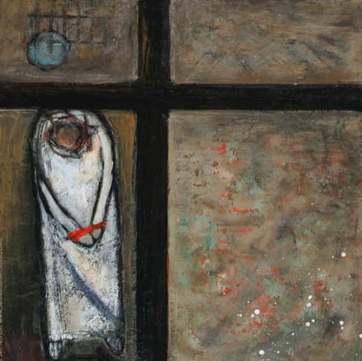

Station One – Jen Norton
BIG Question
What if…
St Peter had not denied knowing Jesus?
See  Think  Wonder 

