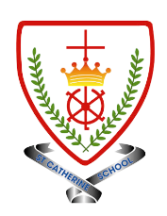
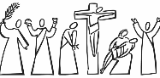
Year 3 - Branch 4
Desert to Garden

Key Vocabulary
 | Mass
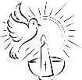 | Sacrament
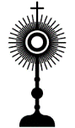 | Eucharist
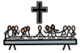 | Last Supper
 | Communion
Scripture |  | Catholic Social Teaching  Community and Participation
  “Take this bread and eat it; this is my body.”  Matt 26:26-29 |  | 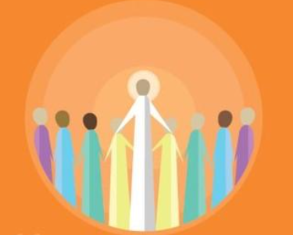  Pope Francis said “Do not be observers of life: get involved like Jesus did”
See  Think  Wonder 


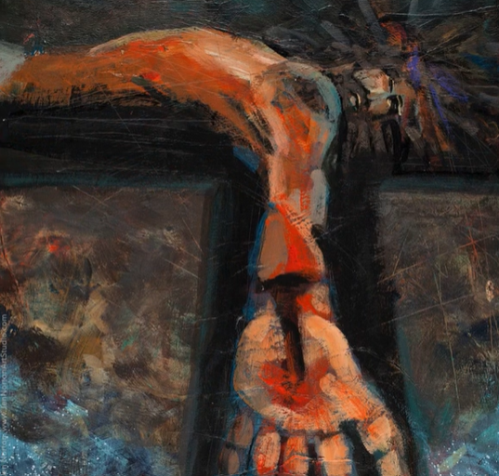
BIG Question
Why is the Last Supper important for Catholics today?
Station Eleven – Jen Norton

