
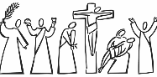
Year 2 - Branch 4
Desert to Garden

Key Vocabulary
 | Easter Vigil | A Mass at midnight when we celebrate the moment Jesus saved all of the world through His resurrection.
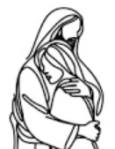 | Kyrie Eleison | ‘Lord have Mercy’ in Latin. It is said as part of The Mass
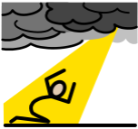 | Sin | Choosing to do what is wrong and turning away from God’s love.
 | Forgiveness | Being loved and pardoned when we are sorry.
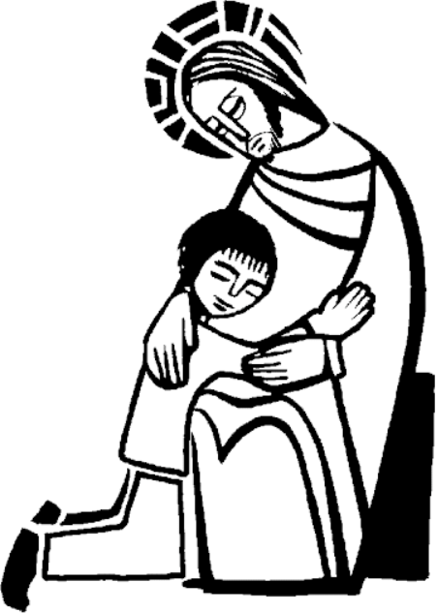 | Reconciliation | The sacrament where God forgives our sins and we make peace with God and the Church.
Scripture |  |  | Catholic Social Teaching  Community and Participation
“Father, forgive them. For they know not what they do.”    Jesus’ words in St Luke’s Gospel |  |  | 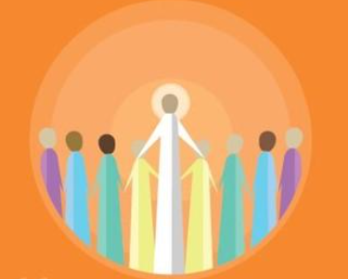  Pope Francis said “Do not be observers of life: get involved like Jesus did”
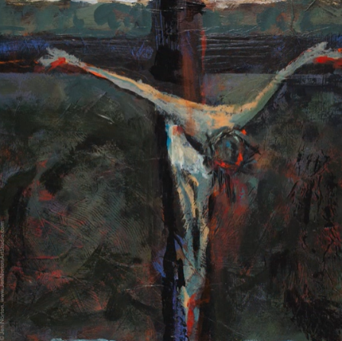
BIG Question
Why is it important to say sorry to God and how can we do this?


Station Twelve – Jen Norton
See  Think Wonder 

