

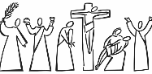
Year 1 - Branch 4
Desert to Garden

 | Temptation | Wanting to do something we know is not right.
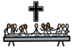 | Last Supper | Jesus and his friends celebrating together. We remember this moment every week in Mass.
 | Crucifixion | Jesus dying on the cross.
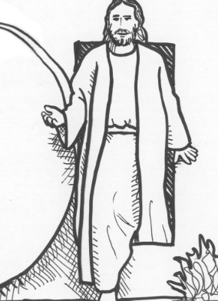 | Resurrection | Three days after dying, Jesus is alive again.
 | Ash Wednesday | The start of Lent. We receive an ash cross on our heads in church.
 | Palm Sunday | The start of Holy Week. Jesus is cheered when he enters Jerusalem.
 | Lent | When we prepare for Easter.
 | Easter | The celebration of Jesus’ Resurrection.
Scripture |  |  | Catholic Social Teaching  Community and Participation
  St Luke’s Gospel |  |  | 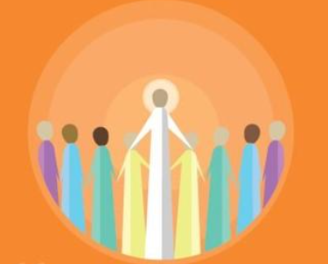  Pope Francis said “Do not be observers of life: get involved like Jesus did”
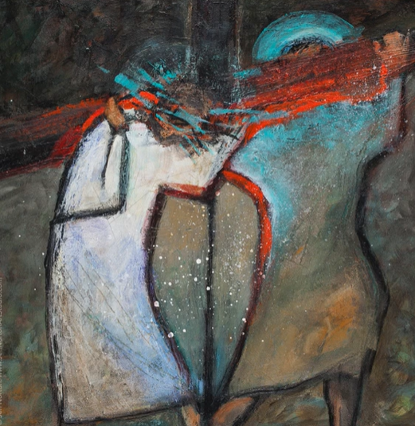

BIG Question
How do Christians prepare during Lent?
See
Think
Wonder

Station Five – Jen Norton

