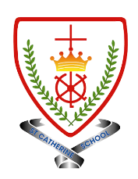
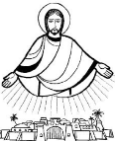
Year 6 - Branch 3
Galilee to Jerusalem

Key Vocabulary
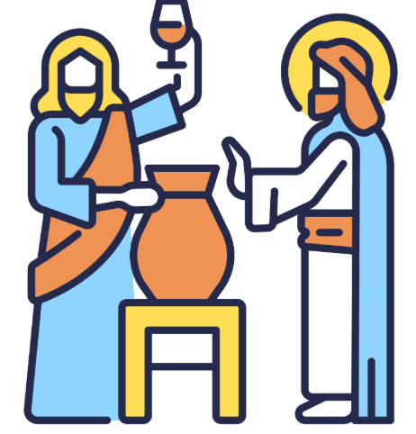 | Cana
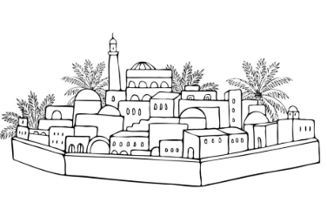 | Bethesda
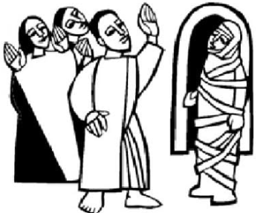 | Lazarus
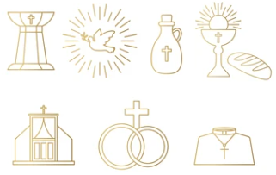 | Sacraments
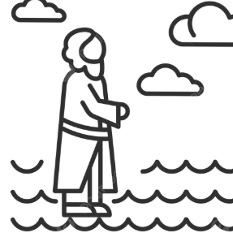 | Signs
 | ‘I am’
Scripture |  |  | Catholic Social Teaching – Solidarity and Peace
  Jesus performed this, the first of his signs, at Cana in Galilee, thereby revealing his glory, and his disciples believed in him.  John 2:12 |  |  |   Blessed are the Peacemakers
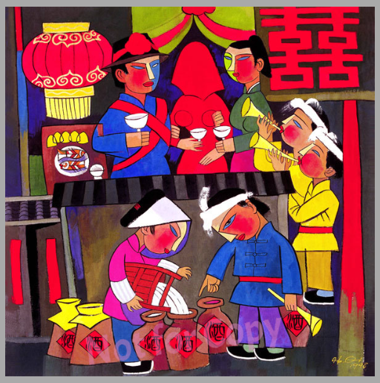

BIG Question
Which of the ‘I am’ statements in St John’s Gospel do you think most clearly teaches who Jesus is for us today? Explain why you think this.

He Qi – Wedding at Cana
See  Think  Wonder 

