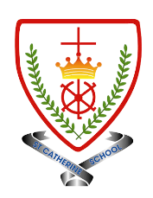
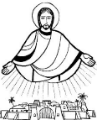
Year 5 - Branch 3
Galilee to Jerusalem

Key Vocabulary
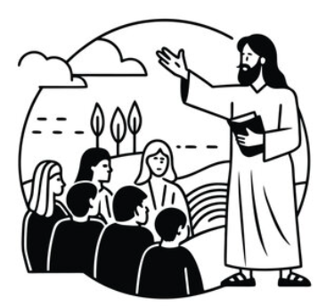 | Beatitude
 | Petition
 | Sermon
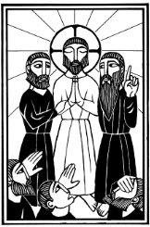 | Transfiguration
 | Our Father
 | Virtue
Scripture |  |  | Catholic Social Teaching – Solidarity and Peace
  “Blessed are the poor in spirit,  for theirs is the kingdom of heaven.”  Mathew 5:3 |  |  |   Blessed are the Peacemakers
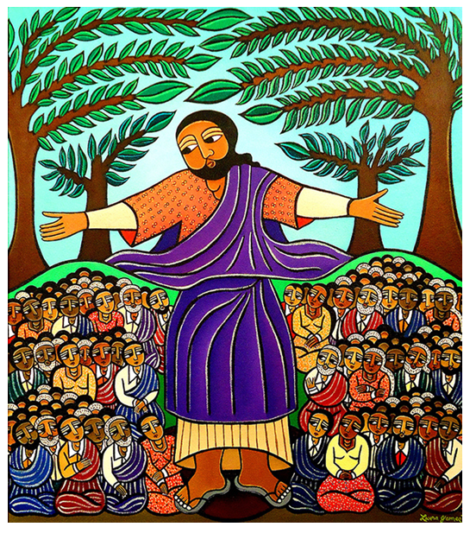

BIG Question
Why is The Our Father such an important prayer?
Laura James – Sermon on The Mount
See  Think  Wonder 

