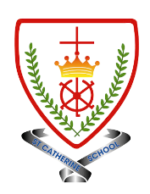
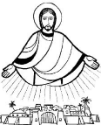
Year 4 - Branch 3
Galilee to Jerusalem

Key Vocabulary
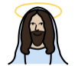 | Christ
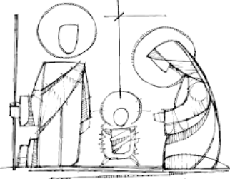 | Incarnation
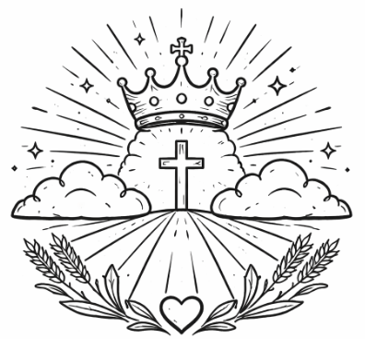 | Kingdom of God
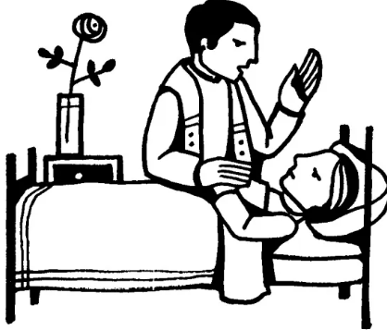 | Sacrament of the Sick
 | Nicene Creed
 | Marginalised
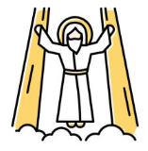 | Messiah
Scripture |  |  | Catholic Social Teaching – Solidarity and Peace
  Jesus immediately reached out his hand and caught hold of him, saying, “O you of little faith, why did you doubt?”  Mathew 14:31 |  |  |   Blessed are the Peacemakers

BIG Question
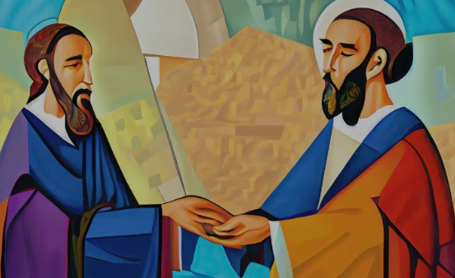
Jesus said to Peter:
Who do you say I am?
How would you answer this question? What evidence would you use to explain your answer.
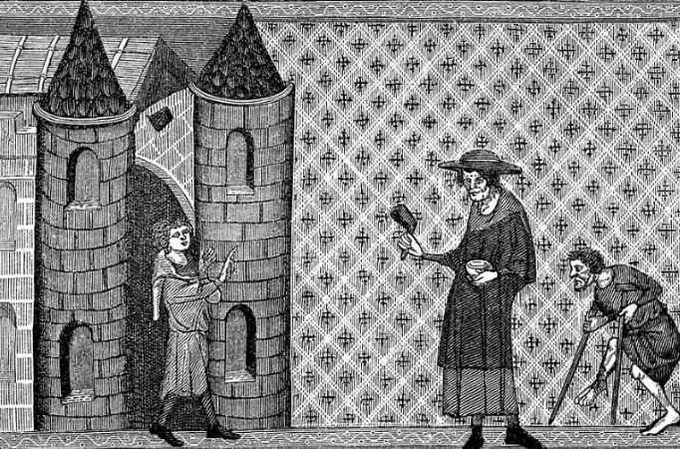
Medieval Carving of Lepers seeking alms

See  Think  Wonder 

