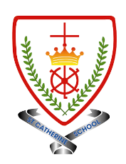
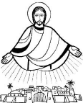
Year 3 - Branch 3
Galilee to Jerusalem

Key Vocabulary
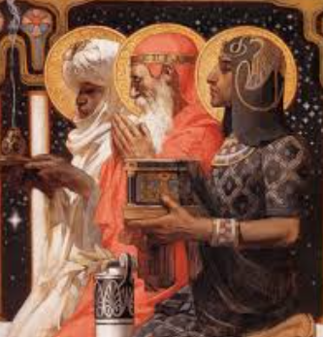 | Adoration
 | Epiphany
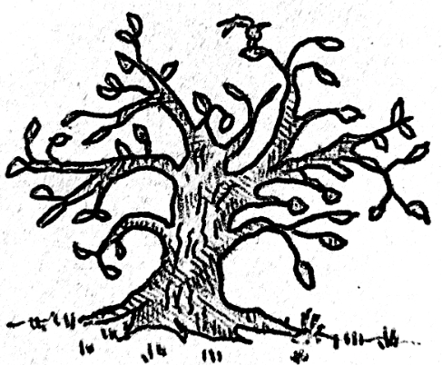 | Kingdom of God
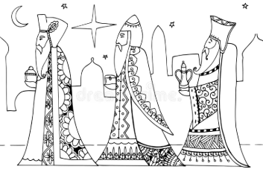 | Magi
 | Miracle
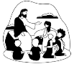 | Parable
Scripture |  |  | Catholic Social Teaching – Solidarity and Peace
  But some seeds fell on rich soil and produced a crop—some a hundred, some sixty, and some thirty times what was sown.  Matt 13:8 |  |  |   Blessed are the Peacemakers

BIG Question
How can we build the Kingdom of God?
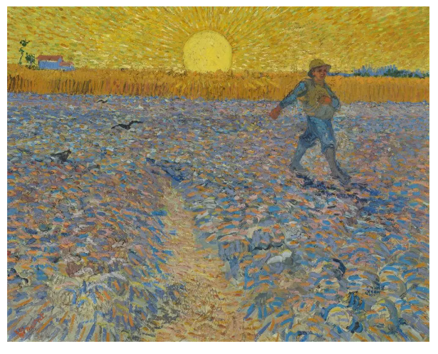

See  Think  Wonder 

The Sower – Vincent Van Gogh

