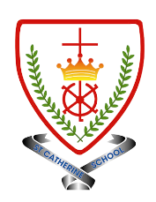
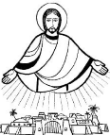
Year 2 - Branch 3
Galilee to Jerusalem

Key Vocabulary
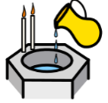 | Baptism | The sacrament that makes us children of God and members of the Church.
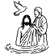 | John the Baptist | The prophet who prepared people for Jesus and baptised Him in the River Jordan.
 | Miracle | A wonderful sign of God’s power and love.
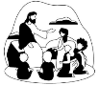 | Parable | A story Jesus told to teach us about God and how to live.
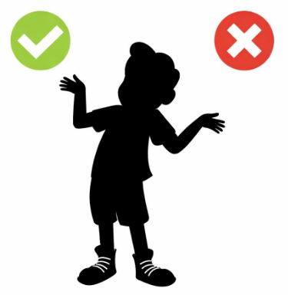 | Temptation | Wanting to do something we know is not right.
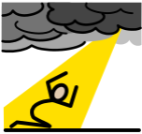 | Sin | Choosing to do what is wrong and turning away from God’s love.
 | Sorrow | Being truly sorry for doing wrong and wanting to change.
 | Forgiveness | Being loved and pardoned when we are sorry.
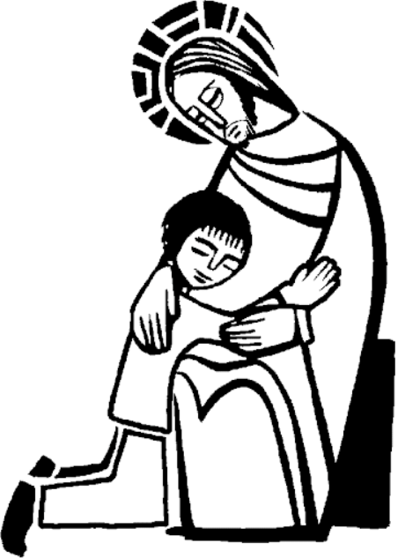 | Reconciliation | The sacrament where God forgives our sins and we make peace with God and the Church.
Scripture |  |  | Catholic Social Teaching – Solidarity and Peace
  There will be more rejoicing in heaven over one sinner who says sorry, than over ninety-nine righteous people who have no need of repentance.  St Luke’s Gospel |  |  |   Blessed are the Peacemakers
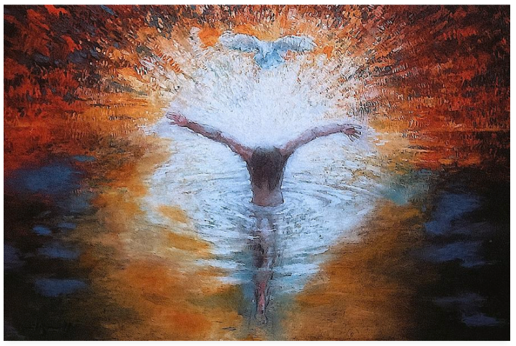

BIG Question
Why is it important to say sorry to God and how can we do this?

See  Think  Wonder 

Baptism of Christ – Daniel Bonnell

