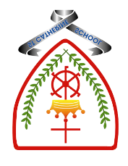

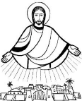
Year 1 - Branch 3
Galilee to Jerusalem

Key Vocabulary
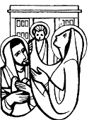 | Presentation | Jesus was taken to God’s house as a baby.
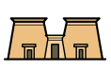 | Temple | A big, special house for God.
 | Mission | A special job from God to love and help.
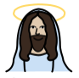 | Son of God | Jesus is God’s Son.
 | Light | Light helps us see; Jesus is our light
 | Candlemas | A day we thank God for Jesus, our light.
Scripture |  |  | Catholic Social Teaching – Solidarity and Peace
  Jesus said: ‘I have come to bring The Good News to the poor.’  St Luke’s Gospel |  |  |   Blessed are the Peacemakers

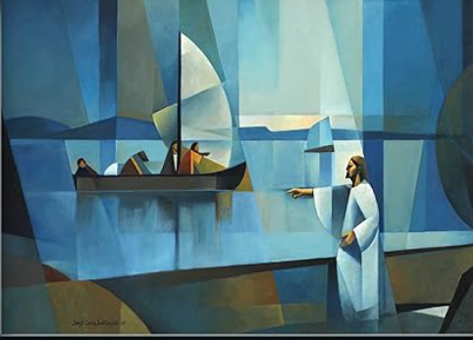
BIG Question
How did people know that Jesus was special?
The Call – Jorge Cocco
See
Think
Wonder

