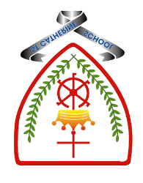
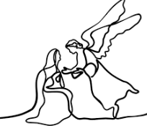

Year 6 - Branch 2

Prophecy and Promise

 | Key Vocabulary
 | Fulfilment
 | Lucan / Matthean
 | Magnificat
 | Mary, Mother of God
 | Old Testament
 | Protagonists
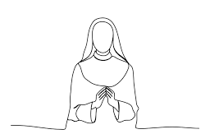 | Religious order
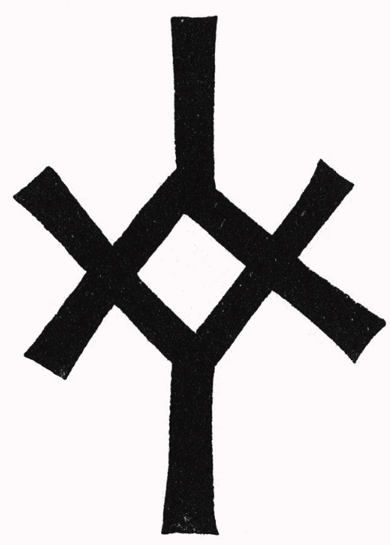 | Salvation history
Scripture |  |  | Catholic Social Teaching
  Lk 1: 26-56  You will name him Jesus. He will be great and will be called Son of the Most High. The Lord God will give him the throne of his ancestor David. |  |  | 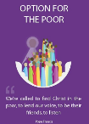  Option for The Poor
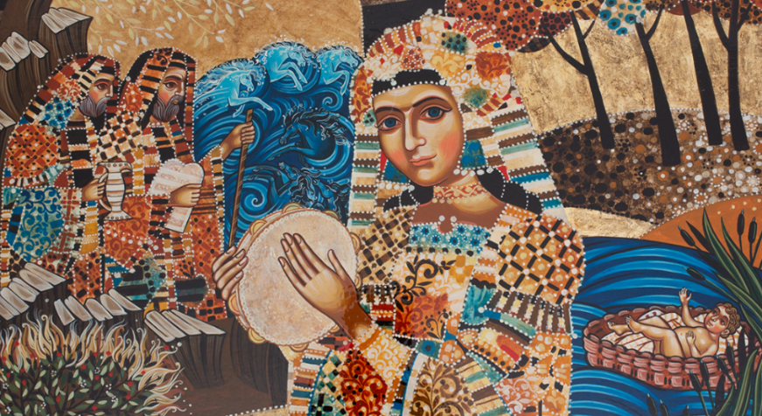

Image: Silvia Dimitrova Miriam

BIG Question
Why is the Magnificat such an extraordinary prayer? How can we learn from the example of Our Lady?

https://www.godwhospeaks.uk/miriam/
See Think Wonder

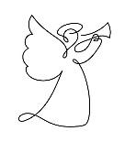 | ♪♪  Tell out my Soul:  T Dudley – Smith

What should I already know?
- Psalms are an ancient way of prayer that are still prayed every day.
- Some words of Psalm 23 to speak or sing.
- God chooses in unexpected ways and especially values those the world overlooks. David, the shepherd was called by God to become a servant king.
Hear
By the end of this unit of study, I would have heard about these key texts:
Old Testament passages that show the importance of women in salvation history, e.g.:
• Genesis 18:1-15; 21:1-7: Sarah
Exodus 1:8-22; 2:1-10: Miriam
• Judges 4:4-11; 5:7-15: Deborah
• 1 Samuel 1:5, 9-11, 26-28: Hannah
• Esther 2:4, 15-17; 3:1-6, 12-13; 4:1-4, 8a-17; 5:1-8; 7:1-6, 9-10; 8:3-12 (Purim): Esther • Lk 1: 26-56: Mary as the fulfilment of Old Testament promises

What will I learn?
Live
By the end of this unit of study, pupils will know that the Church teaches:
Examples of women today who are responding to God’s call in their life. For example, the role of women’s religious orders in the Church today, with reference to at least one example of a Catholic women’s religious order (e.g., Sisters of Mercy, Ursulines, Sisters of Loreto, Daughters of St Paul, Little sisters of the Poor).

Celebrate
By the end of this unit of study, I will know:
The Magnificat is the song of the Mother of God and the song of the Church.
• The Church prays the Magnificat each day at Vespers (evening prayer).
• Some sung settings of the Magnificat.

Believe
By the end of this unit of study, I will know that the Church teaches:
The women of the Old Testament are true protagonists of salvation history (see Pope John Paul II’s address, General Audience, 27 March 1996)
• Mary is the fulfilment of the Old Testament promises and became the ‘Mother of God’ by her ‘Yes’ to God’s plan.

