
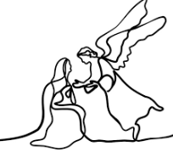
Year 5 - Branch 2
Prophecy and Promise

 | Key Vocabulary
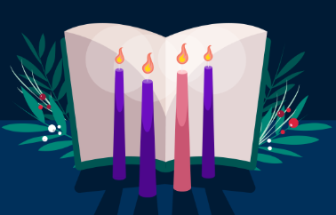 | Advent
 | Anointing
O | Antiphon
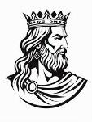 | David
 | Psalm
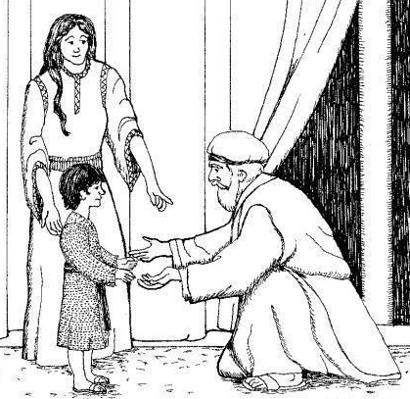 | Samuel
Scripture |  |  | Catholic Social Teaching
  2 Samuel 7: 8-15  I will designate as your heir one of your sons to succeed you, and I shall establish his kingdom forever. |  |  | 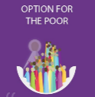  Option for the Poor

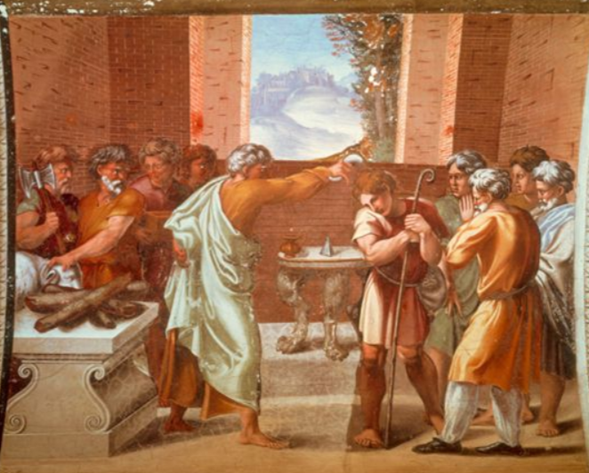

BIG Question
What is significant about where Jesus was born? Why might this be unexpected?

See
Think
Wonder

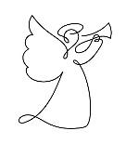 | ♪♪  Once in Royal David’s City:  C. F Alexander

Raphael: 1519

What should I already know?
- Advent is a time of preparation for Jesus’ incarnation at Christmas and for the second coming as King of the Universe.
• The Feast of Christ the King.
The preaching of John the Baptist (Matt 3:1-12 and Mk 1:1-8)

What will I learn?
Hear
By the end of this unit of study, I would have heard about these key texts:
- Scripture passages that speak of David’s life and importance:
• 1 Samuel 16:1-13: anointing of David (a great king)
• 1 Samuel 17:1-11, 32-54: David and Goliath
• 2 Samuel 5:1-5: David becomes king
• 2 Samuel 7: 8-15 God’s covenant with David • 1 Kings 2:1-4, 10-12: David’s death • Psalm 21:1-7, Psalm 23

Live
By the end of this unit of study, pupils will know that the Church teaches:
Psalms are an ancient way of prayer that are still prayed every day.
• How the O Antiphons are expressed in art from around the world (e.g., illuminated manuscripts, sung versions of the O Antiphons).
How the O Antiphons are used by Christians to reflect on the significance of Jesus and his coming at Christmas (e.g., The O Antiphons, by Ansgar Holmberg C.S.J.

Believe
By the end of this unit of study, I will know that the Church teaches:
. There were great kings anointed and chosen in the Old Testament.
• God chooses in unexpected ways and especially values those the world overlooks. David, the shepherd was called by God to become a servant king.
• David became a great king and united his people who loved him (see Psalm 21:1-7).
• For Christians, Jesus fulfils the promises made to David.
• Psalms are part of the Church’s treasury of prayers. In praying psalms David is a model of prayer.

Celebrate
By the end of this unit of study, I will know:
• Some words of Psalm 23 to speak or sing.
• The links between the O antiphons and the Evening Prayer of the Church (Vespers) for 17-23 December.
• The verses of the hymn ‘O Come, O Come Emmanuel’ as expressions of beliefs about who Jesus is.
• The joyful mysteries of the Rosary: the Annunciation, the Visitation, the Nativity of our Lord, the Presentation of the Child Jesus in the Temple, and the Finding of the Child Jesus in the Temple

