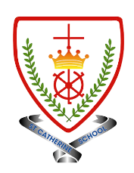
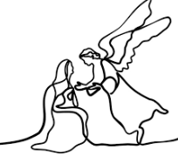
Year 4 - Branch 2
Prophecy and Promise

 | Key Vocabulary
 | Advent
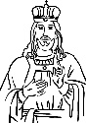 | Christ the King
 | Elijah
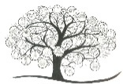 | Jesse tree
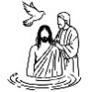 | John the Baptist
 | Prophet
Scripture |  |  | Catholic Social Teaching
  Matt 3:3  “A voice of one calling in the wilderness,  ‘Prepare the way for the Lord, |  |  |   Option for The Poor
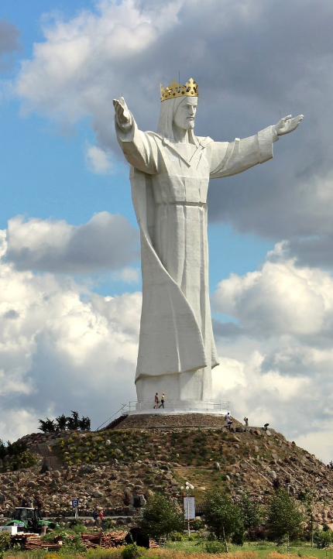

BIG Question
What sort of King is Jesus?

See 
Think 
Wonder 

 | ♪♪  Oh Come, Oh come, Emmanuel.  Traditional

Statue: Świebodzin, Poland,

What should I already know?
- Catholics gather to celebrate Mass where they listen to the words of holy scripture
- How Advent hymns celebrate Jesus as the coming Messiah.
- Some ways that Christians prepare for the coming of Christ during Advent.
What will I learn?
Hear
By the end of this unit of study, I would have heard about these key texts:
- The miracle of the flour and the oil (1 Kings 17:7-14) • Elijah’s encounter with God: the journey 1 Kings 19:4-8, The meeting: 1 Kings 19:9-15 • The preaching of John the Baptist (Matt 3:1-12 and Mk 1:1-8) • Isaiah 40:3 (contained within the gospel accounts) • The ancestry of Jesus (Matt 1:1-17)

Live
By the end of this unit of study, pupils will know that the Church teaches:
• How Christians prepare for the coming of Christ during Advent.
• How Christians use the Jesse tree during Advent, identifying its meaning and representation in art around the world, connecting to God’s plan for salvation.
• How some artists have depicted Jesus Christ as King

Celebrate
By the end of this unit of study, I will know:
• The Feast of Christ the King.
• The Jesse tree.
• ‘He will come again in glory’ from the Nicene Creed

Believe
By the end of this unit of study, I will know that the Church teaches:
• For Christians, the prophets awaken an expectation of the coming of the Messiah in people’s hearts.
• John the Baptist is sent to prepare the way for Jesus.
• In the Advent liturgies, Christians pray for the second coming of Jesus alongside preparing for Christmas.
• Advent is a time of preparation for Jesus’ incarnation at Christmas and for the second coming as King of the Universe.

