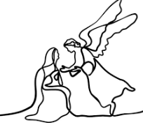
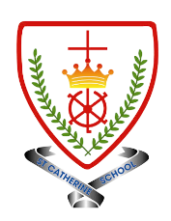
Year 3 - Branch 2
Prophecy and Promise

Key Vocabulary
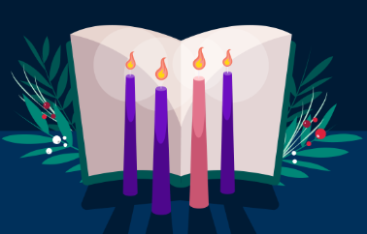 | Advent
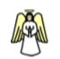 | Angel
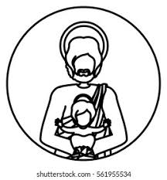 | Joseph
 | Liturgy of The Word
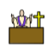 | Mass
 | Sunday
Scripture |  |  | Catholic Social Teaching
  Isaiah 7:14  …she will give birth to a son,  and she will name him Immanuel. |  |  | 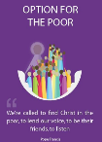  Option for the poor
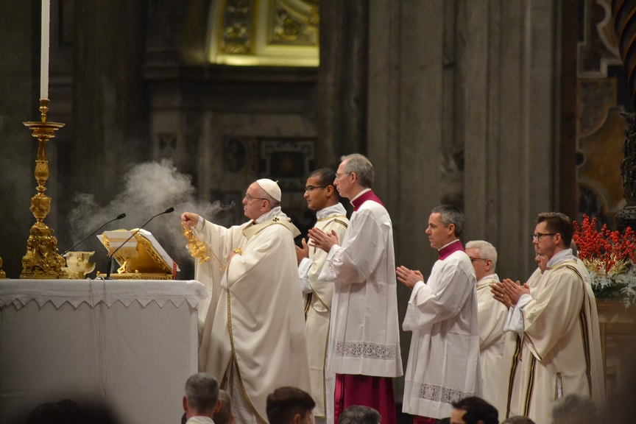
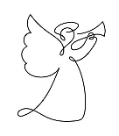 | ♪♪  The First Noel  Traditional


See  Think  Wonder 

BIG Question
What is the Liturgy of The Word and why is it important for Catholics?

What will I learn?
Hear
By the end of this unit of study, I would have heard about these key texts:
- Messiah would be born of a virgin and would be called Immanuel (Is 7:14).
• The Annunciation to Joseph (Matt 1:18-25). • Revisit Lk 1:26-38.

Believe
By the end of this unit of study, I will know that the Church teaches:
- Sunday is the day of the Resurrection of Jesus. Therefore, Christians gather on Sunday.
- Catholics gather to celebrate Mass where they listen to the words of holy scripture (the Liturgy of the Word) and meet Jesus in Holy Communion (the Liturgy of the Eucharist).
- The Liturgy of the Word includes readings from the Old Testament and the New Testament.
- That Jesus birth was foretold by the prophets.
- That Joseph listened to the angel and opened his heart to the Holy Spirit.

Celebrate
By the end of this unit of study, I will know:
• How Catholics use some signs, actions, prayers, and symbols to celebrate Mass, e.g., the sign of the cross, bells, the Kyrie Eleison prayer, etc.
• Hear some of the responses Catholics say at Mass, focusing on the Liturgy of the Word.
• How Advent hymns celebrate Jesus as the coming Messiah.

Live
By the end of this unit of study, pupils will know that the Church teaches:
• Some ways that Christians prepare for the coming of Christ during Advent.
• Representations in art around the world, connecting to the prophecies of Christ’s coming.

What should I already know?
- Angels bring God`s message and are a sign that Jesus is the son of God
- We ask Mary to pray with us and to comfort us in times of need
- How Christians in their local community celebrate the birth of Jesus

