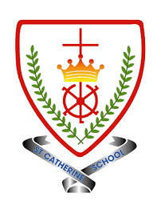
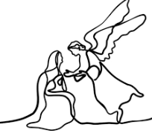
Year 2 - Branch 2
Prophecy and Promise

 | Key Vocabulary
 | Advent | A time of getting ready for Jesus’ birth.
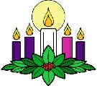 | Advent wreath | A circle of green leaves with four candles to help count the time to Christmas.
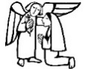 | Annunciation | The story of Angel Gabriel telling Mary that she was to have a baby.
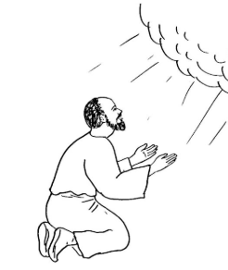 | Isaiah | A prophet that told people a long time ago that a saviour was to be born .
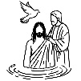 | John the Baptist | Jesus cousin who told people to get ready because Jesus was coming.
 | Magnificat | Mary’s happy prayer saying ‘Yes’ to her special job and praising God and His plan.
 | prophet | Someone chosen by God to share His special message.
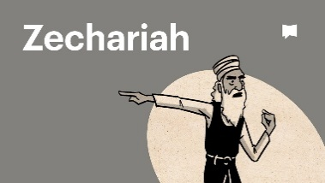 | Zechariah | John the Baptist’s father who heard God’s message from an angel
Scripture |  | Catholic Social Teaching
  Luke 1:28  Hail, Mary. Full of Grace. The Lord is with you. |  | 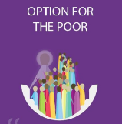  Option for the Poor

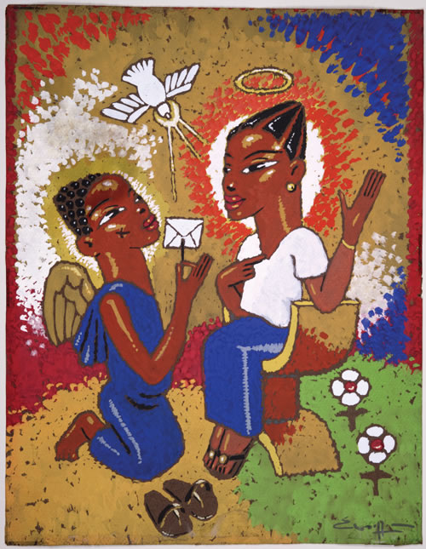
BIG Question
How does the story of John the Baptist help Catholics during
Advent?

See 
Think 
Wonder 
 | ♪♪  Gabriel’s Message:  S. Baring- Gould

Artist Paul Woelfel: The Annunciation

