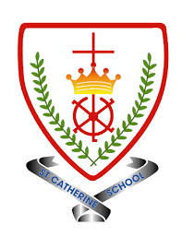
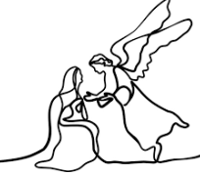
Year 1 - Branch 2
Prophecy and Promise


 | Key Vocabulary
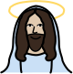 | Jesus | God made man. The baby born in a stable in Nazareth.
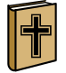 | Bible | The Holy book for Christians. It is full of stories, poems and Jesus’ teachings.
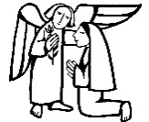 | Annunciation | The story of Angel Gabriel telling Mary that she would have a baby.
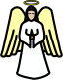 | angels | God’s messengers. They tell people on earth of God’s plan.
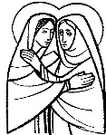 | Visitation | Mary visiting her cousin Elizabeth with great news.
 | Hail Mary | Our prayer to Our Lady
 | Gloria | A hymn of praise to God.
Scripture |  | Catholic Social Teaching
  Luke 1:38  I am The Lord’s servant. |  | 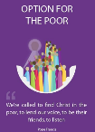  Option for The Poor
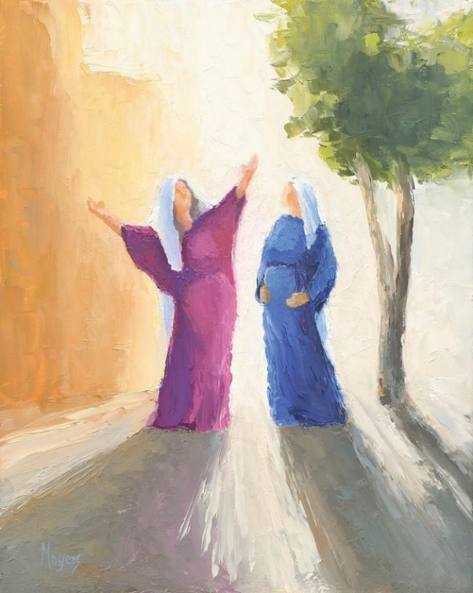
BIG Question
How can Mary help us to be close to Jesus?

See 
Think 
Wonder 
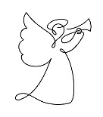 | ♪♪  Mary said Yes!  M. Mangan

Artist Mike Moyers: Visitation

