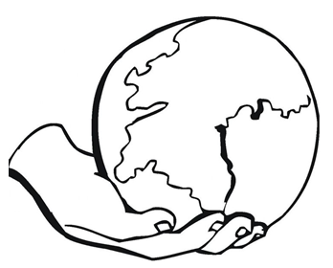
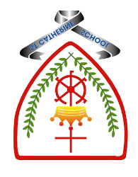

Year 6 - Branch 1
Creation & Covenant

 | Key Vocabulary
 | Creation
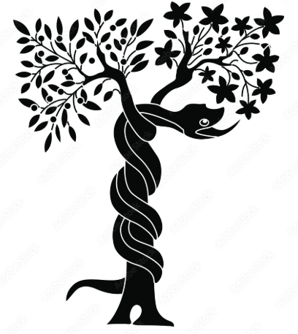 | Fall
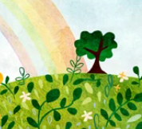 | Eden
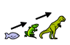 | Evolution
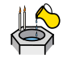 | Baptism
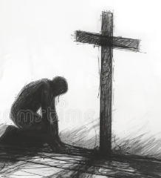 | Salvation
Scripture |  |  | Catholic Social Teaching
  Exodus 3:1-15  14 God said to Moses, “I am who I am. |  |  | 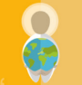  Care for Creation
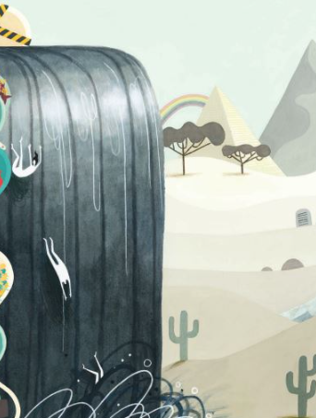


BIG Question
What can Catholics learn from the story of ‘The Fall’ and how might this effect the way they live their lives?

See
Think
Wonder

Image: Big Frieze: Emma Yarlett

What will I learn?
Hear
By the end of this unit of study, I would have heard about these key texts:
• The second account of Creation (Genesis 2:5-10, 15-23, 3:1-7,9-13, 17-19) • Jn 1:1-5, 16-18 • The Nicene Creed • Laudato Si’ 66-67
• The literary forms employed in the Genesis account.
• The Genesis account of Creation and Fall is not a literal scientific description, but expresses beliefs about God, the world, and human beings (see CCC 159).

Believe
By the end of this unit of study, I will know that the Church teaches:
• The world is in disarray because humans choose to do evil again and again. This is called original sin; the story of Adam and Eve explains why the world is no longer as good as it was in the beginning. (YCfK 22)
• In Jesus, God restored humanity’s relationship with him.
• Baptism is the first sacrament of the forgiveness of sins. It unites Christians with Jesus Christ, who dies and rises, and strengthens the gifts of the Holy Spirit.
• Belief in God as sustainer and source of the universe is compatible with the scientific account of the beginnings of the universe and the theory of evolution.

Celebrate
By the end of this unit of study, I will know:
The symbols in the Sacrament of Baptism that point to a Christian’s new life in Christ • The Church teaches that the Nicene Creed allows all believers to make a common statement of their faith.

Live
By the end of this unit of study, pupils will know:
Many scientists are Christians and they do not see any conflict between their faith and science.
• The work of Catholic scientists in contributing to the scientific account of the beginnings of the universe (e.g., the work of Mendel and Lemaitre). The ways in which some sin is social and embedded in social structures (cf. CCC 1868-69).

What should I already know?
- Jesus’ summary of the law (Matt 22:36-40)
- We can develop habits that will help us accomplish what is good. These habits are called virtues.
- Catholic Social Teaching helps us to see that loving our neighbour demands a commitment to social change and transformation: ‘We profoundly belong together and are fundamentally dependent on one another’. (YC 321)

