
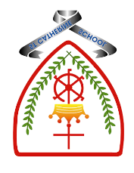

Year 5 - Branch 1
Creation & Covenant

 | Key Vocabulary
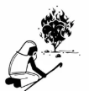 | Moses
 | Exodus
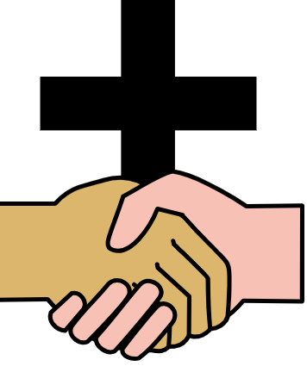 | Covenant
 | Virtue
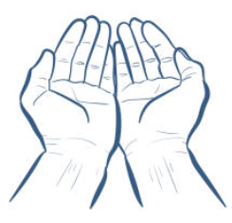 | Grace
 | Sinai
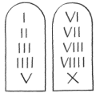 | Commandments
Scripture |  |  | Catholic Social Teaching
  Exodus 3:1-15  14 God said to Moses, “I am who I am. |  |  |   Care for Creation
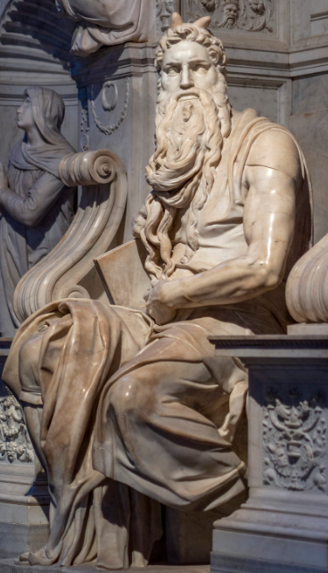


BIG Question
What do the Ten Commandments, and the story of Moses teach Catholics about living well and loving others? How might this effect the way they live their lives?

See
Think
Wonder

Image: Moses by Michaelangelo (1515)
Basilica de San Pietro; Rome

What will I learn?
Hear
By the end of this unit of study, I would have heard about these key texts:
The Moses story, focusing on the two key events of the call and the covenant:
• The Burning Bush (Ex 3:1-15)
• The Sinai covenant and the Ten Commandments (Ex 19:3-8, 20:1-17) • Jesus’ summary of the law (Matt 22:36-40)

Believe
By the end of this unit of study, I will know that the Church teaches:
• A covenant is a binding agreement between God and human beings, which makes them his people.
• God made several covenants throughout history – with Noah, Abraham, Moses, and David.
• God gives the Ten Commandments to help human beings live good and happy lives.
• That Jesus teaches that the most important commandments are to love God and to love other people.
• Catholic Social Teaching helps us to see that loving our neighbour demands a commitment to social change and transformation: ‘We profoundly belong together and are fundamentally dependent on one another’. (YC 321)

Celebrate
By the end of this unit of study, I will know:
• That sin is the deliberate spoiling of our friendship with God and each < other.
• We can develop habits that will help us accomplish what is good. These habits are called virtues.
• Virtues are practical wisdom (prudence), justice, fortitude, and temperance (also known as the cardinal virtues). Through God’s grace we can enjoy the theological virtues of faith, hope, and love.

Live
By the end of this unit of study, pupils will know:
Examples of acting with great love (e.g., Little Way week shows the importance of doing small things with great love). •
What growing in virtue could mean in their school (e.g., Jesuit Pupil Profile, Minnie Vinnies)

- The Abrahamic covenant (Gen 15:1-6)
- Covenant with Abraham is the foundation of the faith of the people of the Old and New Testaments:
- Judaism and Christianity.
- The life and work of a person who was an example of faith made active in love.
What should I already know?

