
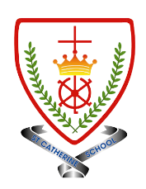
Year 4 - Branch 1
Creation & Covenant
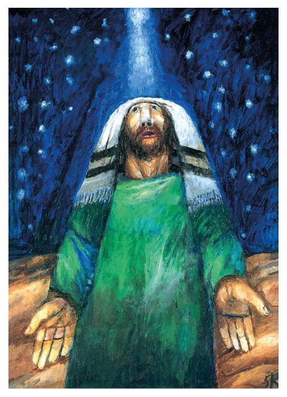
 | Key Vocabulary
 | Abraham  Sarah  Isaac  Joseph | These are the special people we will encounter in our topic. Each one showed trust in God’s love for them.    Think: How can we show the same trust?
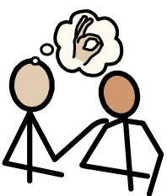 | Forgiveness
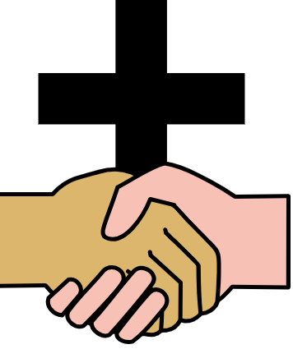 | Covenant
 | Virtue
 | Faith
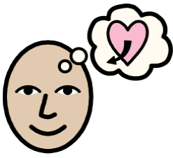 | Hope
 | Love
Scripture |  |  | Catholic Social Teaching
  Genesis 15:1-6  Abram put his trust in the Lord, and because of this the Lord was pleased with him and accepted him |  |  |   Care for Creation

BIG Question
How does Abraham’s story help Catholics trust God and live with faith, hope and love??

See 
Think 
Wonder 

Image: Sieger Köder
Abraham: The night of Hebron

What will I learn?
Hear
By the end of this unit of study, I would have heard about these key texts:
• The story of Abraham, focusing on the following key texts:
• The call of Abram (Gen 12:1-5) • The Abrahamic covenant (Gen 15:1-6) • Abraham and Sarah (Gen 18:1-15) • Abraham and Isaac (Gen 22:1-18)
Believe
By the end of this unit of study, I will know that the Church teaches:
. God’s covenant with Abraham is the foundation of the faith of the people of the Old and New Testaments: Judaism and Christianity
• Faith is believing in God, trusting what God reveals, and following God’s loving purpose to live a good life.
• Through living out virtues of faith, hope, and love (sometimes referred to as charity), Christians are drawn into a closer relationship with the Holy Trinity.
• Abraham is a model of how to pray

Celebrate
By the end of this unit of study, I will know:
•Age-appropriate extracts from prayers of faith in God from the Catholic tradition. (For example, Ps 40:1, the St Therese prayer, ‘May today there be peace within’, St John Henry Newman’s ‘Mission of my Life’, Bl Charles de Foucauld’s ‘Prayer of Abandonment’.)

Live
By the end of this unit of study, pupils will know:
The virtues of faith, hope, and love.
• The life and work of a person who was an example of faith made active in love, e.g., the intervention of Cardinal Manning in the London dockworker’s strike.

What should I already know?
· The first account of the Creation, Genesis 1:1-2:4.
• That all human beings are made in God’s image and all people have dignity and are created equal.
• How the praise of Creation is expressed in the prayer and Liturgy of the Church.

