

Year 3 - Branch 1
Creation & Covenant

 | Key Vocabulary
 | Genesis
 | Creator
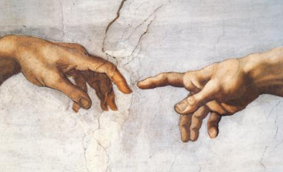 | Image and likeness
 | Dignity
 | Equality
Scripture |  |  | Catholic Social Teaching
  Genesis 2:3  He blessed the seventh day and set it apart as a special day. |  |  |   Care for Creation
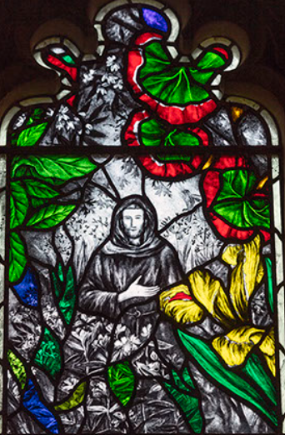


BIG Question
What does the Creation story teach Catholics about God, the world, and how we should treat each other?
See 
Think 
Wonder 

Stained-glass window at Christ Church Cathedral Oxford created by John Reyntiens

What will I learn?
Hear
By the end of this unit of study, I would have heard about these key texts:
- The first account of the Creation, Genesis 1:1-2:4.
• Extracts from either Psalm 8 or 19 in praise of Creation

Believe
By the end of this unit of study, I will know that the Church teaches:
• God is the Creator of the Universe who made everything out of ‘free and unselfish love’ (YC 2).
• That all human beings are made in God’s image and all people have dignity and are created equal.
A way in which human beings’ image (imitate) God is through care for each other, and that caring for Creation is one of the ways we care for each other. Additionally, failing to care for Creation is a way people turn away from God’s love.
• The dignity of all human beings is one of the principles of Catholic Social Teaching.

Celebrate
By the end of this unit of study, I will know:
• Extracts from a psalm of Creation.
• How the praise of Creation is expressed in the prayer and Liturgy of the Church (e.g., St Francis’s Canticle of the Creatures; the Offertory prayers; a Prayer for our Earth in Laudato Si’).

Live
By the end of this unit of study, pupils will know:
• Ways in which we can show care for God’s world (stewardship) as part of our care for each other.
• Ways in which people can give thanks for the blessing of Creation, including spending time in prayer

What should I already know?
- That God made a covenant with Noah to save all living things.
- Baptism is the first Sacrament, which welcomes people into the Church.
- Different ways we can show care for God`s world.

