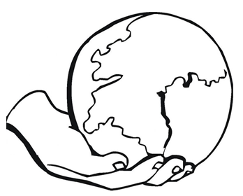
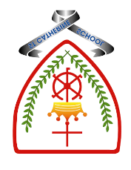

Year 2 - Branch 1
Creation & Covenant

 | Key Vocabulary
 | God | The creator of all things
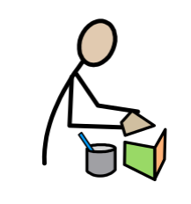 | Father | God who made us all and loves us all
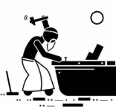 | Noah | A special person who listened to God and followed His plan.
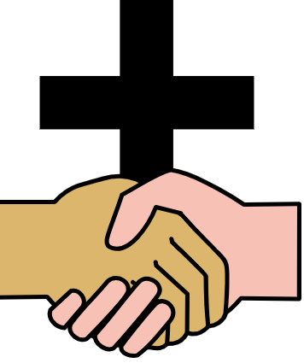 | Covenant | A serious promise between God and His people.
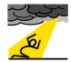 | Sin | Things we think or do to turn away from God and His love for us
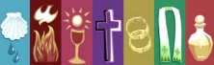 | Sacrament | A way of with being with Christ at a special time in our lives.
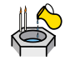 | Baptism | The Sacrament that joins us with God in His family
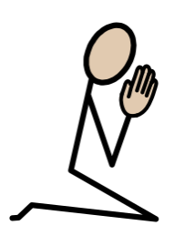 | Psalm | Ancient prayers praising God that are written like songs. They are found in The Old Testament of The Bible.
Scripture |  |  | Catholic Social Teaching
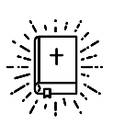  Genesis 9:7-17  That is the sign of the promise which I am making to all living beings. |  |  | 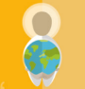  Care for Creation
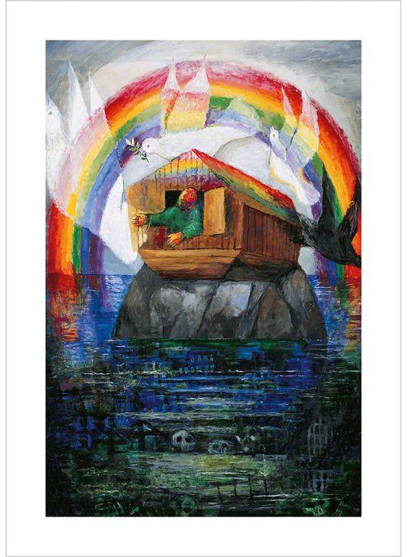
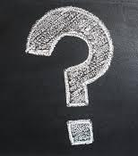
BIG Question

What does God’s covenant with Noah teach us about belonging to God’s family and looking after the world?
See
Think
Wonder

Artist: Sieger Köder – Noah’s Ark

What will I learn?
Hear
By the end of this unit of study, I would have heard about these key texts:
• The story of Noah: Genesis 9:7-17
• Psalm 139

Believe
By the end of this unit of study, I will know that the Church teaches:
• God makes a covenant (promise) with Noah to save all living things.
• That people in the story of Noah turned away from God and chose to act badly; this is behaviour called sin.
• The Sacrament of Baptism is when a person becomes part of the Christian family and promises to love God.
• That the Christian Bible is split into two parts, the Old Testament, and the New Testament.

Celebrate
By the end of this unit of study, I will know:
• Psalms are prayers to praise God.
• Sacraments are living signs of Jesus’ love for all people.
• Baptism is the first sacrament which welcomes people into the Christian family.

Live
By the end of this unit of study, pupils will know that the Church teaches:
Ways in which we can show care for God’s world (stewardship) as part of our care for each other.
How a baby is baptised in the Catholic Church.

What should I already know?
- That God created the world in 7 days.
- The first two people on Earth were Adam and Eve
- That on the last day God rested.

