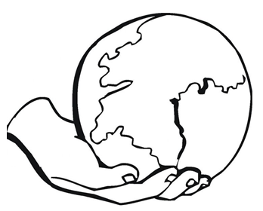
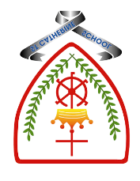

Year 1 - Branch 1
Creation & Covenant

 | Key Vocabulary
 | God | The creator of all things
 | Father | God who made us all and loves us all
 | Creation | How all things in the world were made
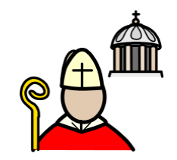 | Pope Francis | The leader of our Church
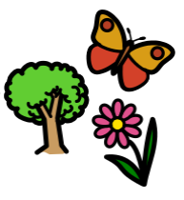 | Laudato Si’ | A special message telling us how to care for God’s Creation
 | Our Father | A prayer to God given to us by Jesus
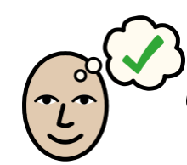 | creed | What we believe as Catholics.  ‘I believe in…’
Scripture |  |  | Catholic Social Teaching
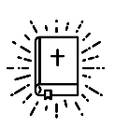  Genesis 1:1-4, 24-26  In the beginning God created the heavens and the earth. |  |  | 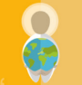  Care for Creation
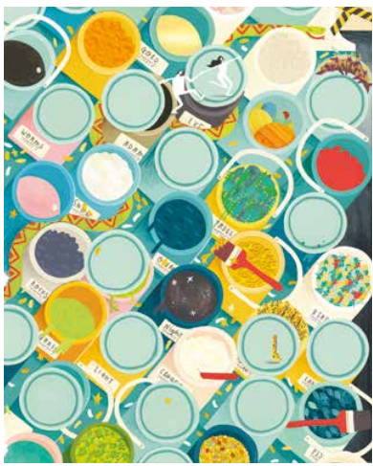


See 
Think 
Wonder 

BIG Question
Why do we call the world a gift from God?
How should we treat Creation?

Artist Emma Yarlett: Big Frieze

What will I learn?
Hear
By the end of this unit of study, I would have heard about these key texts:
• The Creation story in Genesis 1:1-4, 24-26
• The opening of the Nicene Creed ‘I believe in one God, the Father almighty, maker of heaven and earth, of all things visible and invisible’.
• An introduction to Laudato Si’ 13.
Believe
By the end of this unit of study, I will know that the Church teaches:
• That all that is comes from God.
• God is our Father.
• God’s love and care for humans is experienced through the beauty and order of Creation.
• Prayer is a way we draw closer to God.
Celebrate
By the end of this unit of study, I will know:
• That praying is a way people draw close to God.
• That, as a community, the Church prays the Creed and the Our Father to pray to God and worship him.

Live
By the end of this unit of study, pupils will know that the Church teaches:
• God wants us to love and care for the world because the world is God’s gift to us.
• Caring for the world is one of the ways we love and care for each other.
• How a community in another part of the world cares for Creation.

Celebrate
By the end of this unit of study, I will know:
• That praying is a way people draw close to God.
• That, as a community, the Church prays the Creed and the Our Father to pray to God and worship him.

What should I already know?
- God made the world
- God made animals
- We must take care of God`s world

