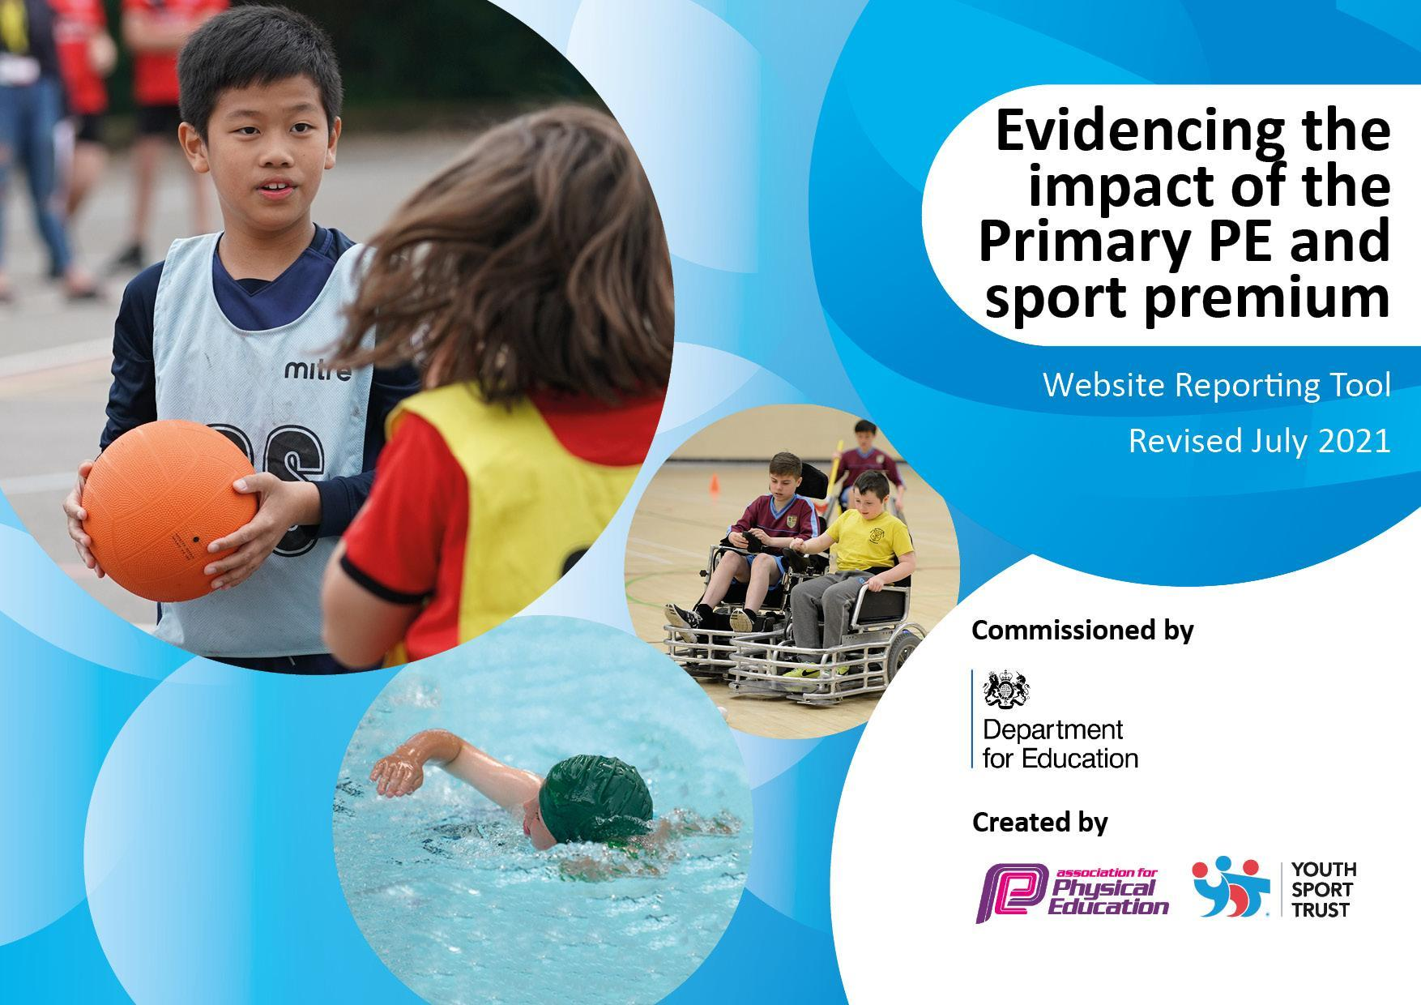
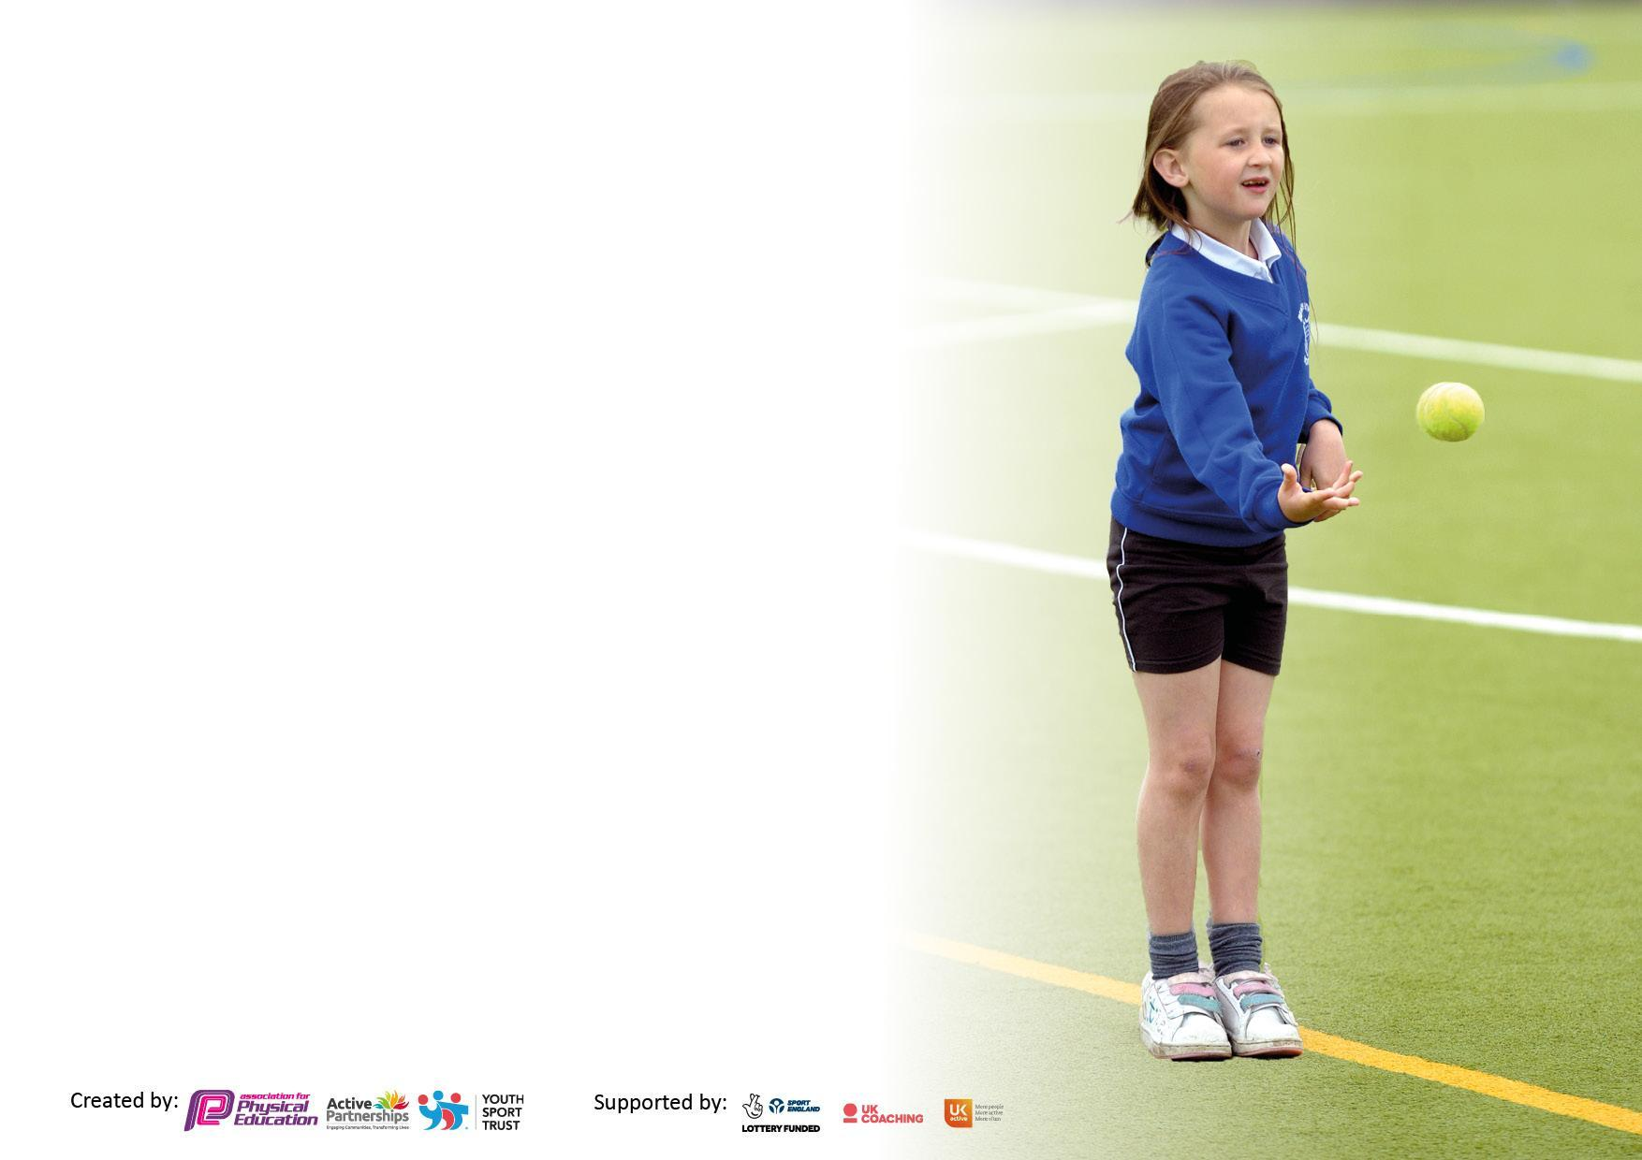

It is important that your grant is used effectively and based on school need. The Education Inspection Framework makes clear there will be a focus on ‘whether leaders and those responsible for governors all understand their respective roles and perform these in a way that enhances the effectiveness of the school’.

Under the Quality of Education Ofsted inspectors consider:
Intent - Curriculum design, coverage and appropriateness
Implementation - Curriculum delivery, Teaching (pedagogy) and Assessment
Impact - Attainment and progress

To assist schools with common transferable language this template has been developed to utilise the same three headings which should make your plans easily transferable between working documents.

Schools must use the funding to make additional and sustainable improvements to the quality of Physical Education, School Sport and Physical Activity (PESSPA) they offer. This means that you should use the Primary PE and sport premium to:

- Develop or add to the PESSPA activities that your school already offer
- Build capacity and capability within the school to ensure that improvements made now will benefit pupils joining the school in future years
- The Primary PE and sport premium should not be used to fund capital spend projects; the school’s budget should fund these.

Pleasevisitgov.ukfortherevisedDfEguidanceincludingthe5keyindicatorsacrosswhichschoolsshoulddemonstrate animprovement.Thisdocumentwillhelpyoutoreviewyourprovisionandtoreportyourspend.DfEencouragesschools to use this template as an effective way of meeting the reporting requirements of the Primary PE and sport premium.

We recommend you start by reflecting on the impact of current provision and reviewing the previous spend.

Schools are required to publish details of how they spend this funding, including any under-spend from 2019/2020, as well as on the impact it has on pupils’ PE and sport participation and attainment. All funding must be spent by 31st July 2022.

We recommend regularly updating the table and publishing it on your website throughout the year. This evidences your ongoing self-evaluation of how you are using the funding to secure maximum, sustainable impact. Final copy must be posted on your website by the end of the academic year and no later than the 31st July 2021. To see an example of how to complete the table please click HERE.

Details with regard to funding
Please complete the table below.

Total amount carried over from 2020/21 | £0
Total amount allocated for 2021/22 | £17,700
How much (if any) do you intend to carry over from this total fund into 2022/23? | £0
Total amount allocated for 2022/23 | £17,700
Total amount of funding for 2022/23. To be spent and reported on by 31st July 2023. | £17,700

Swimming Data
Please report on your Swimming Data below.

Meeting national curriculum requirements for swimming and water safety.
N.B. Complete this section to your best ability. For example you might have practised safe self-rescue techniques on dry land which you can then transfer to the pool when school swimming restarts.
Due to exceptional circumstances priority should be given to ensuring that pupils can perform safe self rescue even if they do not fully meet the first two requirements of the NC programme of study
What percentage of your current Year 6 cohort swim competently, confidently and proficiently over a distance of at least 25 metres?  N.B. Even though your pupils may swim in another year please report on their attainment on leaving primary school at the end of the summer term 2023.  Please see note above | 70%
What percentage of your current Year 6 cohort use a range of strokes effectively [for example, front crawl, backstroke and breaststroke]?  Please see note above | 70%
What percentage of your current Year 6 cohort perform safe self-rescue in different water-based situations? | 70%
Schools can choose to use the Primary PE and sport premium to provide additional provision for swimming but this must be for activity over and above the national curriculum requirements. Have you used it in this way? | No

Action Plan and Budget Tracking
Capture your intended annual spend against the 5 key indicators. Clarify the success criteria and evidence of impact that you intend to measure to evaluate for pupils today and for the future.

Academic Year: 2022/23 | Total fund allocated: 17,700 | Date Updated:
Key indicator 1: The engagement of all pupils in regular physical activity – Chief Medical Officers guidelines recommend that primary school pupils undertake at least 30 minutes of physical activity a day in school |  |  |  | Percentage of total allocation:
 |  |  |  | 39%
Intent | Implementation |  | Impact
Your school focus should be clear what you want the pupils to know and be able to do and about  what they need to learn and to  consolidate through practice: | Make sure your actions to achieve are linked to your intentions: | Funding allocated: | Evidence of impact: what do pupils now know and what can they now do? What has changed?: | Sustainability and suggested next steps:
Active lunchtimes – Sports coaches to provide a range of sports on offer for children to trial and take part in during their lunchtime. 3 x a week. Through liaising with the PE lead, class teachers and lunchtime staff, coaches to encourage and support those children who are less likely/keen to take part in physical activity without a provided, adult led activity provided. | The employment of a sports coach to provide physical activities over 1.5 hours of the KS1 and KS2 lunchtime. This will take place 3 times a week. | £1755 | All children in reception, KS1 and KS2 had the opportunity to engage in structured physical activities during their lunchtime through a variety of different sports, including archery, handball, football, netball, basketball target practice. Children’s skills in accuracy, agility and knowledge of how to play new sports improved.  Increased physical activity and confidence in those not usually accessing the sports equipment during the lunch hour. | We will continue to invest in a sports coach to provide active lunchtimes and train up sports leaders in year 5 to continue the support for EYFS and KS1 the following year.
For pupils to have access to free after school sporting activities throughout the whole year. | Outside coaches and school staff provide sports activities each term with enough places for all pupils to attend at least one sporting club a year with most attending more. | £5171 | Every child had the opportunity to attend at least one sporting club a year. Most were able to attend more than one. Some attended a sports club each term.  A number of children experienced weekly training sessions and sport at a competitive level, including football, athletics, swimming and cross country running. | We will continue to work with the same outside providers for after school activities.  Our aim for next year is to have more school staff running sports clubs, with the intention of entering borough competitions. Netball is already confirmed for next academic year.
Key indicator 2: The profile of PESSPA being raised across the school as a tool for whole school improvement |  |  |  | Percentage of total allocation:
 |  |  |  | 14%
Intent | Implementation |  | Impact
Your school focus should be clear what you want the pupils to know and be able to do and about  what they need to learn and to  consolidate through practice: | Make sure your actions to achieve are linked to your intentions: | Funding allocated: | Evidence of impact: what do pupils now know and what can they now do? What has changed?: | Sustainability and suggested next steps:
To show the importance of PESSPA through investment in equipment to ensure all children have access to all equipment and resources needed, ensuring coaches and teachers can provide quality first teaching. | Ensure all necessary sporting equipment is fully stocked and replaced when needed. Mats and mat trolly for gymnastics, footballs, basketballs and athletics equipment to be purchased. | £2408 | A number of resources have been purchased which has ensured that each child is able to access the necessary equipment for lessons, active lunchtime sessions and after school clubs. | We will continue to audit and restock equipment for all sporting activities provided at St Catherine to ensure quality first teaching is possible.

Key indicator 3: Increased confidence, knowledge and skills of all staff in teaching PE and sport |  |  |  | Percentage of total allocation:
 |  |  |  | 5%
Intent | Implementation |  | Impact
Your school focus should be clear | Make sure your actions to | Funding | Evidence of impact: what do | Sustainability and suggested
what you want the pupils to know | achieve are linked to your | allocated: | pupils now know and what | next steps:
and be able to do and about | intentions: |  | can they now do? What has
what they need to learn and to |  |  | changed?:
consolidate through practice:
Re – establish a netball club, after the departure of the school staff who ran the club previously. PE lead to support external ‘England Netball’ accredited coach to run this and through this, learn how to umpire in order to do this confidently in borough matches moving forward. | PE lead will be skilled up in netball coaching and umpiring and able to share knowledge with other staff members. | £975 | The pupils in the squad have made excellent progress and we will be entering the mixed netball league next year in addition to the mixed rally and girls rally – borough competitions. The PE lead has acquired (and continues to) knowledge in how to coach netball and umpire. | PE lead to share knowledge with other staff members in order to train them in how to coach and umpire so there are a number of staff who can facilitate and help run league matches and support in borough competitions.  The squad will enter the borough league and competitions next year.
Staff to observe enrichment lessons delivered by coaches. | Staff will be upskilled by observing the delivery of enrichment sessions and will continue these sessions/deliver their own within their class enrichment time, allowing the pupils to be further emerged in a range of sports they would not be exposed to through delivery of just the PE curriculum. | (budgeted below) | Staff feel more secure and confident in delivering their own PE lessons and the continuation of the enrichment activity. | Staff will be more confident in delivering their own PE lessons next year. All staff to teach their class PE lessons for at least a term next academic year, with increased confidence and skill.
Key indicator 4: Broader experience of a range of sports and activities offered to all pupils |  |  |  | Percentage of total allocation:
 |  |  |  | 30%
Your school focus should be clear | Make sure your actions to | Funding | Evidence of impact: what do | Sustainability and suggested
what you want the pupils to know | achieve are linked to your | allocated: | pupils now know and what | next steps:
and be able to do and about | intentions: |  | can they now do? What has
what they need to learn and to |  |  | changed?:
consolidate through practice:
To provide children with the opportunity to experience new and different sporting activities through offering enrichment sessions to all classes throughout the year. | Children in upper KS2 to receive initial training as lunchtime leaders, during enrichment sessions in order to support the coaches during active lunchtimes.  During the summer term – increase provision by providing EYFS with enrichment sessions. All staff working with the nursery and reception class to attend and observe the coach as part of CPD.  Dance workshop provided to give children access to high quality dance workshop. Class teachers to attend as part of CPD. | £4891  £400 | KS2 leaders will become more confident and skilled in delivering active lunchtime sessions to younger pupils in the school, who in turn will take part in more structured physical activities during their lunchtimes.  All children have been given to opportunity to experience a number of different sports, outside of the PE curriculum, including country dancing, archery and handball.  Staff will have the skills to continue the delivery of these sessions during their enrichment sessions, through observing the coach. | KS2 Lunchtime leaders who shadowed the coach will use their knowledge gained continue to provide opportunities for EYFS and KS1 children next year.  Staff can continue to deliver enrichment sessions next year, or provide an extra-curricular club using the knowledge they have gained through their observations and CPD.

Key indicator 5: Increased participation in competitive sport |  |  |  | Percentage of total allocation:
 |  |  |  | 12%
Intent | Implementation |  | Impact
Your school focus should be clear | Make sure your actions to | Funding | Evidence of impact: what do | Sustainability and suggested
what you want the pupils to know | achieve are linked to your | allocated: | pupils now know and what | next steps:
and be able to do and about | intentions: |  | can they now do? What has
what they need to learn and to |  |  | changed?:
consolidate through practice:
To resource equipment for activities included within the competitive borough sports we compete in.  Subscription to UDPSSA  Uxbridge district | Coaches and school staff delivering training sessions for pupils attending borough competitions to have access to a full range and complete sets of equipment, similar to those used at borough competitions – in particular – district sports/netball/football.  Through this subscription we are part of the borough team and can enter and organise inter- school competitions. | £1975  £125 | 2nd place in the borough swimming gala, with a number of children winning individual medals for 1st, 2nd, 3rd place.  Winners of the2023 Borough District sports, with high number of children winning individual medals for 1st, 2nd, 3rd place.  Football league– finished joint top of the league.  Football cup – reached the quarter finals.  Cross country – St Catherine pupil came in first place. | To ensure sporting competitions can continue to run.  To enter the netball league and rally’s next academic year. We will also enter the swimming gala, cross country, district sports, rounders tournament and football cup, league and Packham cup next year.  We will continue to be a part of the UDPSSA next year to ensure we are able to enter the borough competitions.

Signed off by
Head Teacher: | P. Doherty
Date: | 18.9.23
Subject Leader: | S Doherty
Date: | 18.9.23
Governor: | M O’Brien
Date:

